Practice our rhyme with actions until you can remember all of your number bonds to 10

0 and 10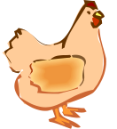(flap elbows)
My pet hen

1 and 9(thumbs up)
Now I’m fine

2 and 8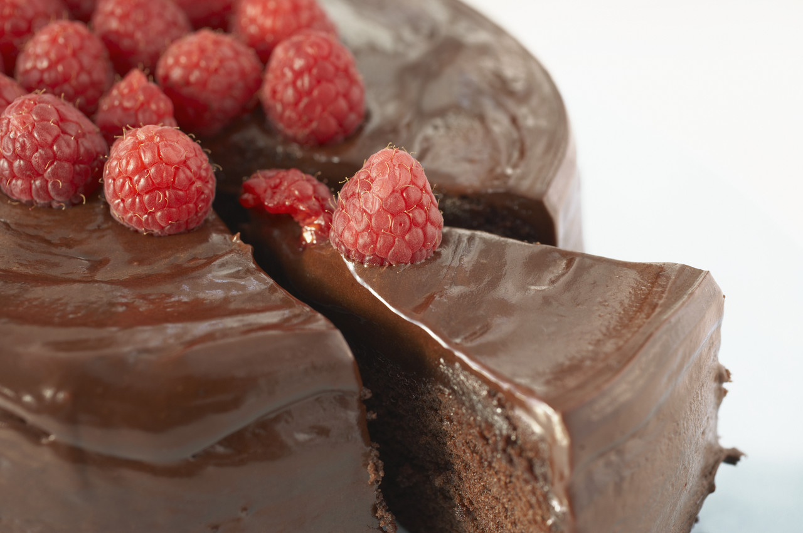(mime eating)
cake on a plate

3 and 7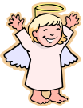(flap wings)
Angels in heaven

4 and 6 (mime juggling)
I like tricks

5 and 5(BIG smile)
Glad I’m alive

6 and 4(point and wag finger)
That’s the law

7 and 3 (arm round Friend)
You and me

8 and 2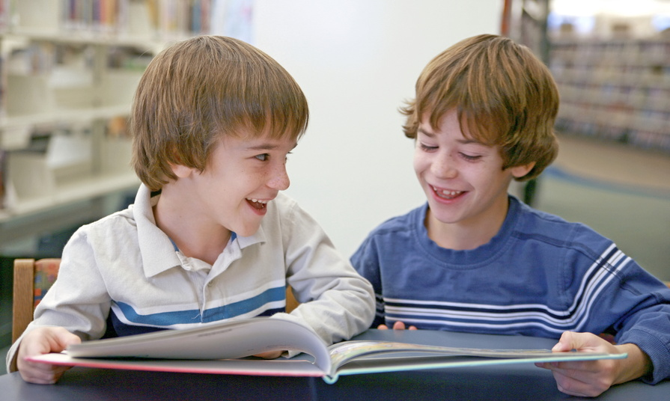(high five a friend)
I like you

9 and 1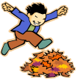(both arms up high)
Let’s have fun

10 and 0 (superman pose)
I’m a hero

