Helping your child with English: on-line learning suggestions
Many of the following links take you to websites where there are free games, resources and activities that will provide your child with additional curriculum-based learning for English. Some have ‘teacher’s notes’, which may help you as parents to guide learning. Many also offer resources for all subjects. Whilst some websites will provide additional options to buy additional resources – we are not suggesting that you need to do this. Of course, we also encourage you to read as much as possible with your child, encourage them to read widely and to use the local library, if you are able.
If you wish to refer to the National Curriculum at any point, please see the link below:
https://www.gov.uk/government/collections/national-curriculum

1. EYFS (BBC)
https://www.bbc.co.uk/programmes/articles/5RMpbn1X8tMkMQgw0GRhz8L/early-years-foundation-stage-eyfs
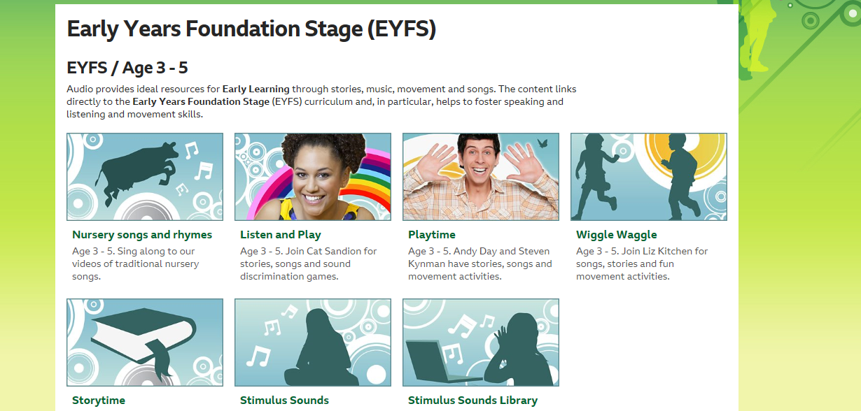

2. BBC Bitesize KS1 (includes phonics games, SPAG and comprehension)
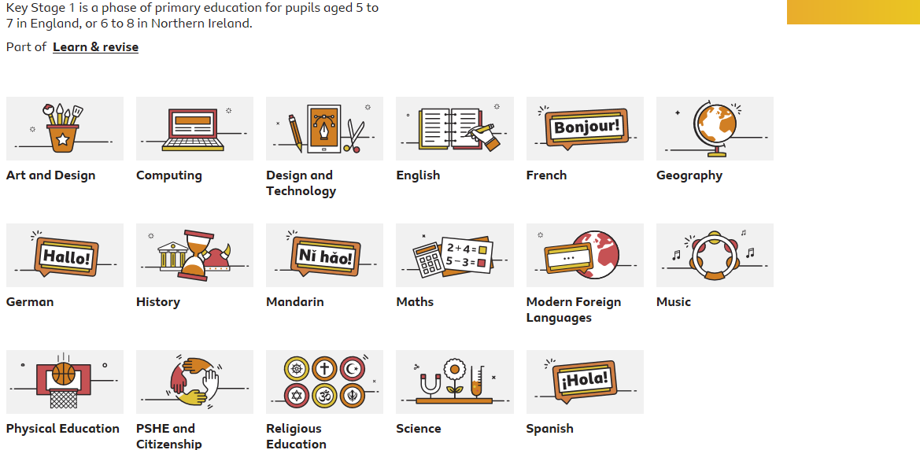
https://www.bbc.co.uk/bitesize/levels/z3g4d2p
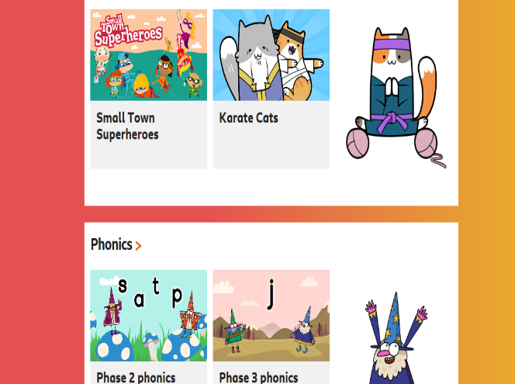

2. BBC Bitesize KS2
https://www.bbc.co.uk/bitesize/levels/zbr9wmn

3. Suitable for all ages – BBC School Radio (includes ‘teacher guides’ that can be used by parents, video clips and animations) https://www.bbc.co.uk/programmes/p007g5y4
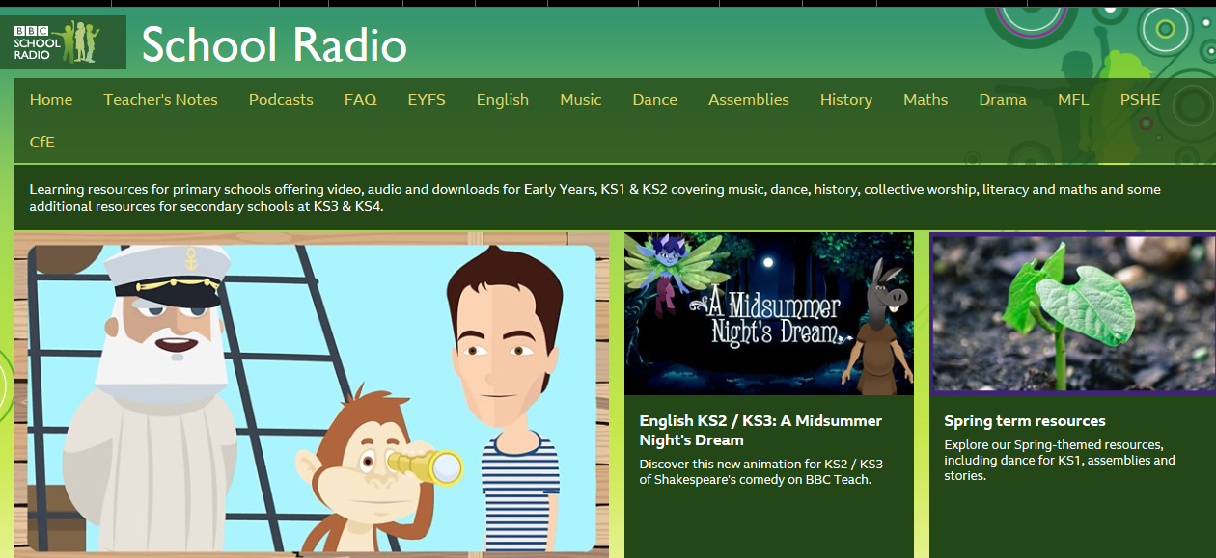

3. Suitable for all ages – BBC School Radio (includes ‘teacher guides’ that can be used by parents, video clips and animations)

https://www.bbc.co.uk/programmes/p007g5y4
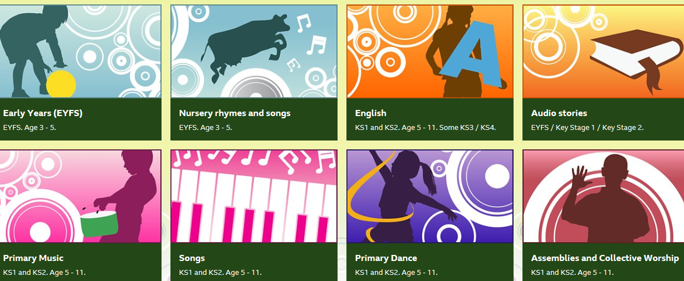

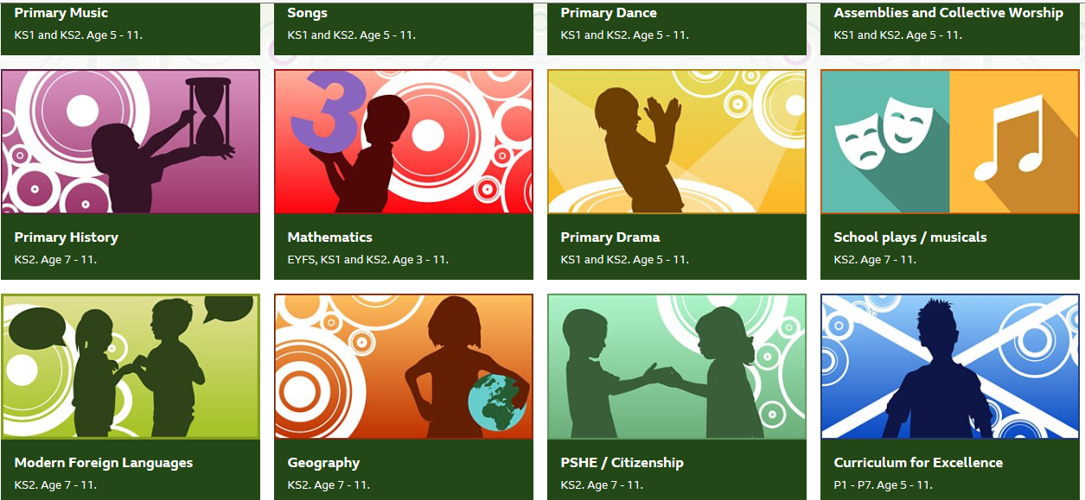

4. Oxford Owl for Home (aged 3-11) Free e-books, games, information and activities for English and Maths, including phonics, spelling and times tables!
https://www.oxfordowl.co.uk/for-home/

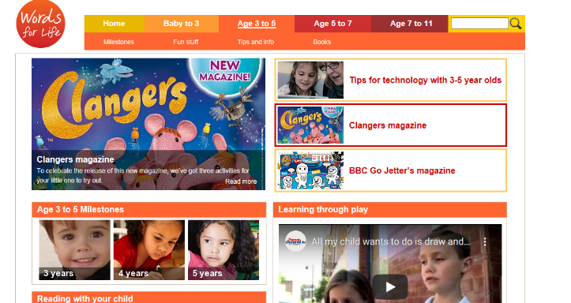
5. National Literacy Trust (all ages – go to ‘Resources’ then ‘Resources for Parents and Families’) Age categories: Baby-3, 3-5, 5-7 and 7-11
https://literacytrust.org.uk/

Includes new website ‘Small Talk’ with information and activities for 0-5 years
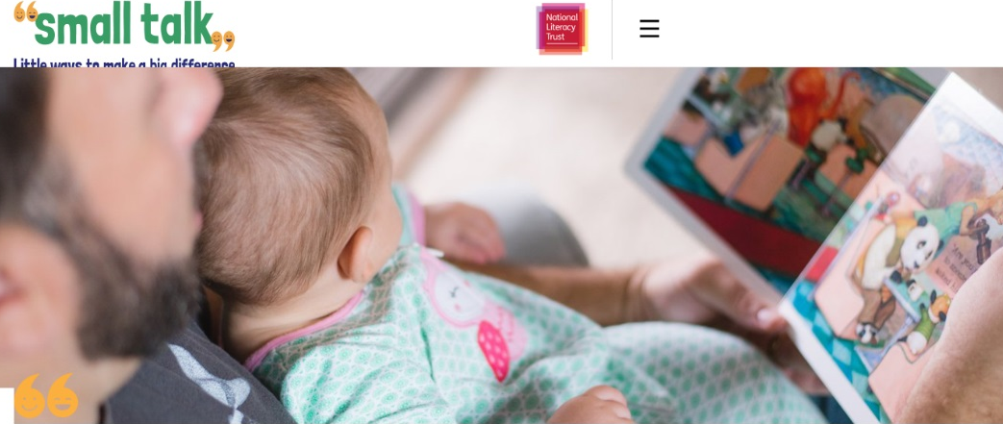
https://small-talk.org.uk/

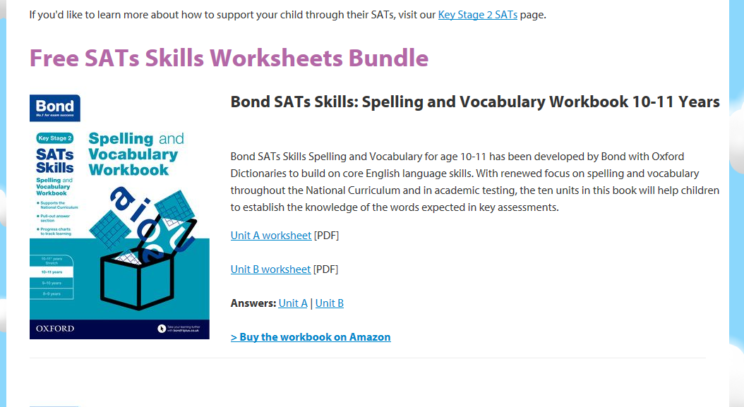
6. Free comprehension and SPAG activities for KS2 (Oxford Owl)

https://www.oxfordowl.co.uk/for-home/school-year/free-sats-skills-worksheets

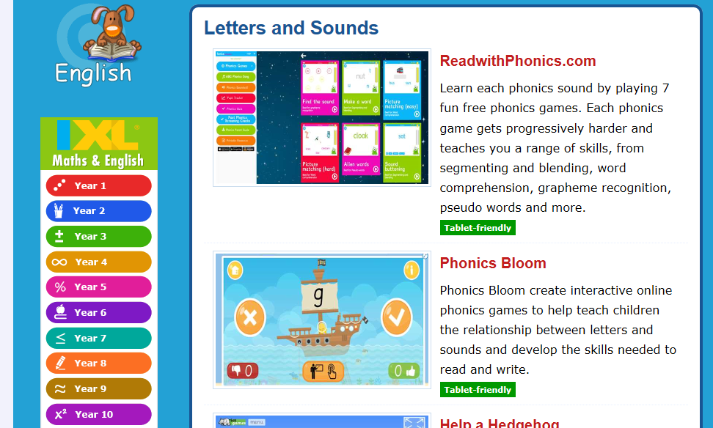

7. Topmarks (suitable for all ages) https://www.topmarks.co.uk/
Links to games and activities for primary aged children including phonics games, reading activities, spelling activities, tablet / non-tablet friendly choices, links to other online learning, many subjects covered.

8. Primary Homework Help (Interactive games, links and free resources for spelling and grammar) Other subjects also available.
http://www.primaryhomeworkhelp.co.uk/interactive/literacy.html#7

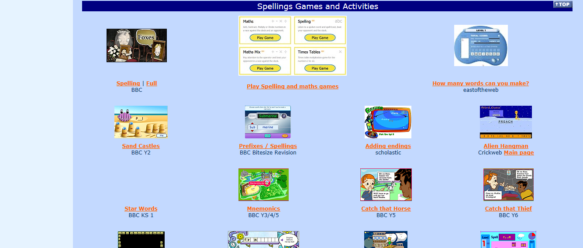

9. The Literacy Shed (ages indicated – aimed at primary schools, but some may not
suitable for the very young children, so please follow the guidance). There is a ‘Key Stage 1 box’ you can choose.
There are many lovely, short films and animations to use as a stimulus for discussion, ‘visual text’ reading skills and writing activities. Many come with prompts for the adults to use alongside the clips.
The Literacy Shed site is completely free and has an extensive amount of resources, without having to subscribe to ‘The Literacy Shed Plus’.
https://www.literacyshed.com/home.html
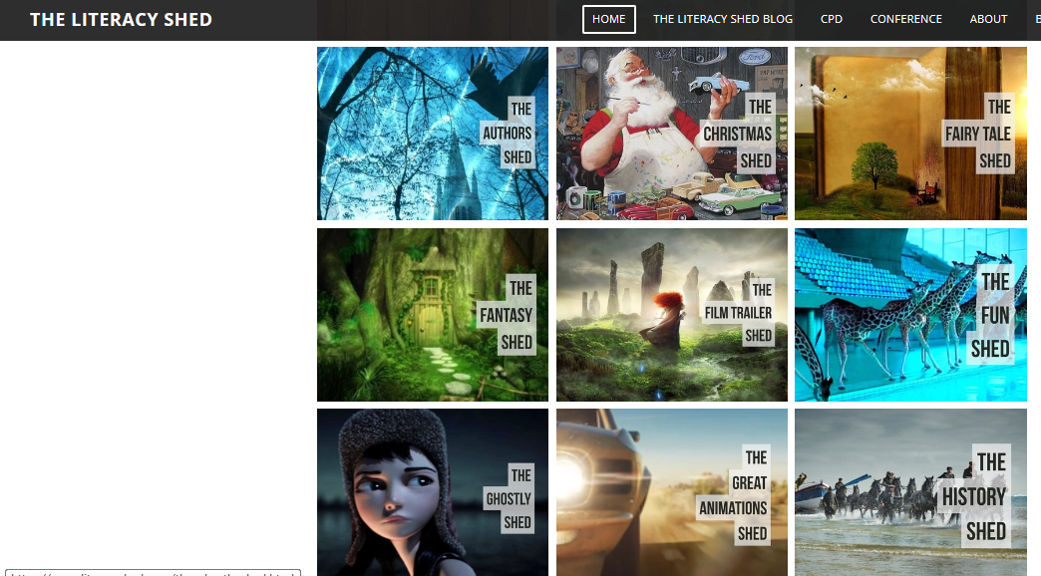

10. CBeebies and CBBC
https://www.bbc.co.uk/iplayer/episodes/b00jdlm2/cbeebies-bedtime-stories
Although CBeebies is aimed at very young viewers, the website actually contains many links to programmes of interest for all. For example, ‘Where in The World’ gives children an insight into the lives of children across the world – the similarities and differences in terms of foods, languages, schooling, transport and hobbies.
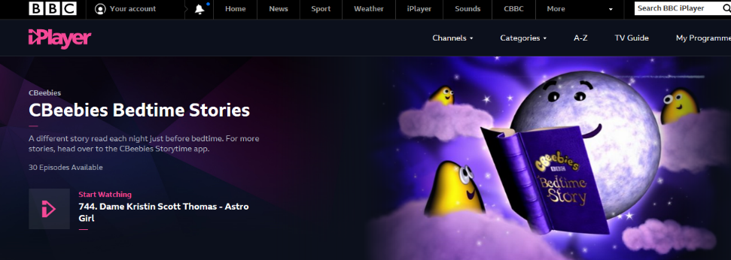
‘Andy’s Adventures’ also looks at history and geography. In terms of stories, there are lovely stories to share, including animated adventures with Beatrix Potter’s ‘Peter Rabbit’, whilst CBBC includes links to the ‘Horrible Histories’ series and adaptations of books such as Jacqueline Wilson’s The Worst Witch.
CBeebies also has ‘Bedtime Stories’ to listen to as well as adaptations of Fairytales.
Encouraging KS1 and KS2 children to apply what they have seen, heard and learnt through ‘summarising’ can be a fun and interactive way of recording their learning. For example, they could write a film or book review for others – you could use a template such as the ones below or the children could create their own.

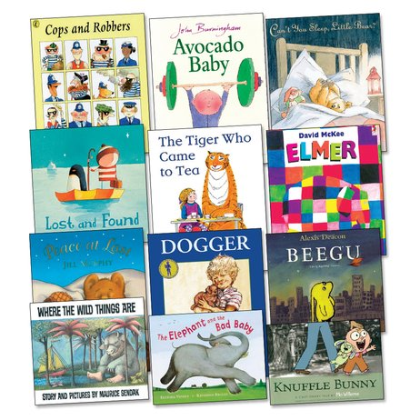
What to Read?

Please encourage your children to read widely and for pleasure. Reading books (non-fiction and fiction) comics, magazines, e-books and more all supports your child’s reading and writing skills.
If you are looking for books that are widely recommended or are year group appropriate, (Nursery– Year 6), follow these links for ideas and inspiration:

The Reading Spine (Pie Corbett)
https://shop.scholastic.co.uk/reading-spine (Has year group recommended reads from Nursery- Year 6)

Oxford Owl
https://www.oxfordowl.co.uk/ (On-line, free e-books and guidance for parents)
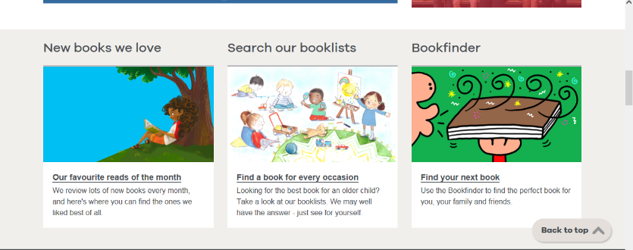
The Book Trust
https://www.booktrust.org.uk/ (‘Book finders’, recommendations, news and more!)

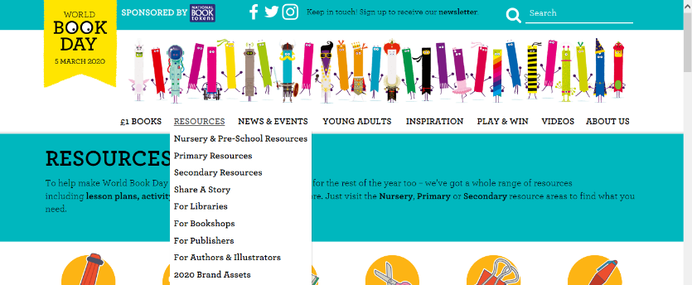
World Book Day
https://www.worldbookday.com/ (Resources, audio stories read by authors, activities)

Thank you for your continued support.

