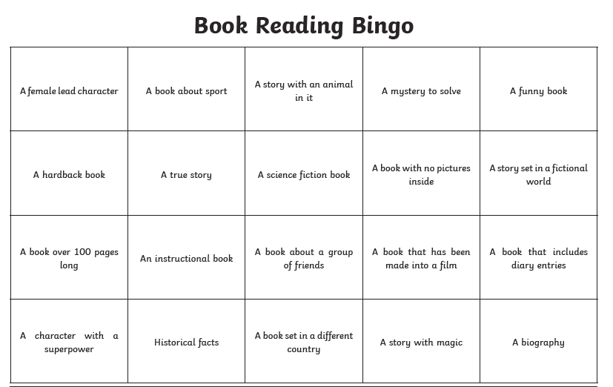
Reading challenge! See how many of these squares you can complete! Maybe you could print the sheet and write the book title and author in each square or write down the books you read in your home learning book along with the title of each bingo square. You could pick one or more of these books and create a book review for it. Happy reading!

