Creative Activity  Look at Claude Monet’s painting below called  ‘Bridge over a Pond of Water Lilies’.  What do you like about the painting?  Can you use resources at home to recreate it – you could use:  paint, pencils, chalk or natural resources from  the garden.  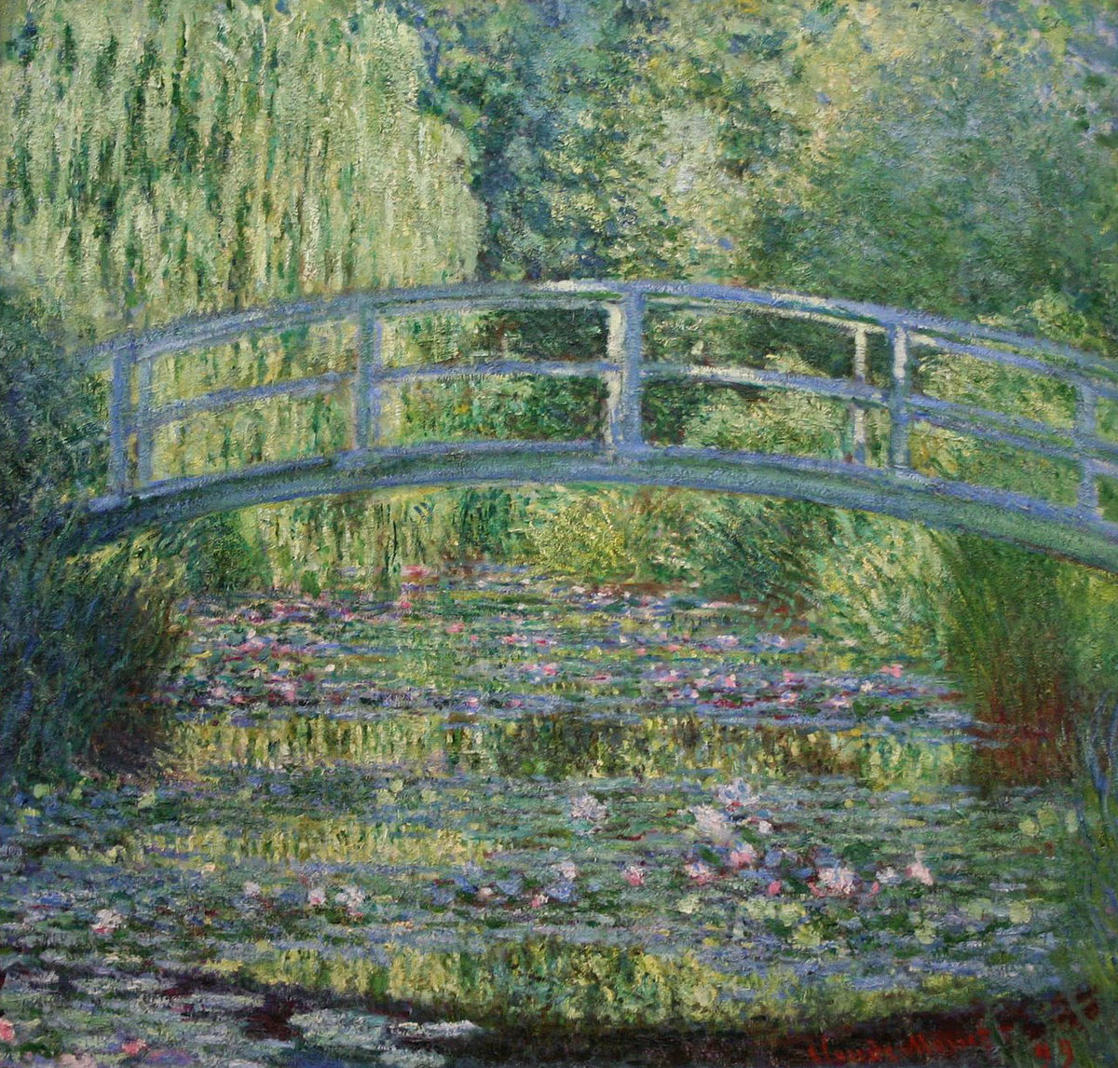 | Practical Activity  Can you use recycled materials you have at home to make a bird feeder?  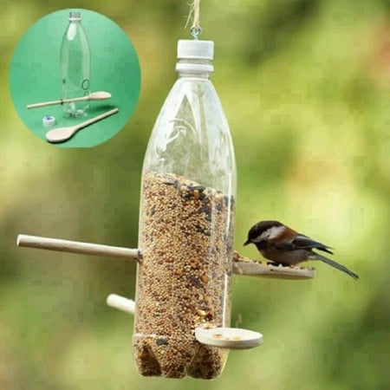  There are some examples below and lots more ideas online.  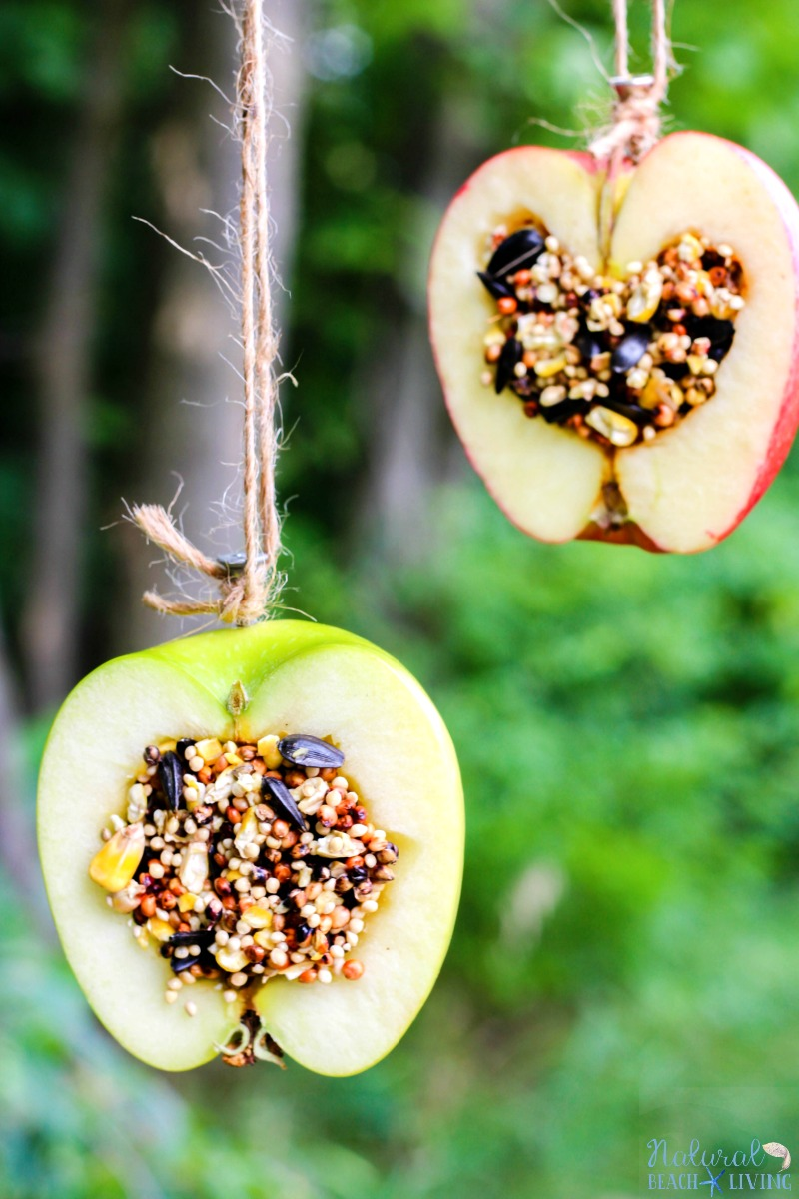  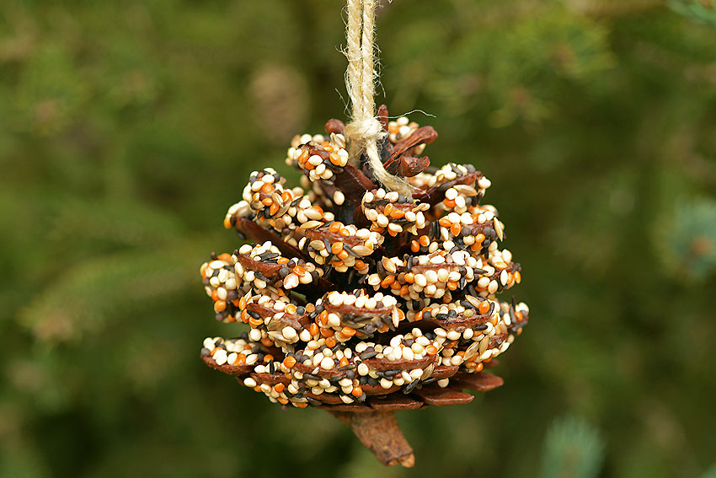  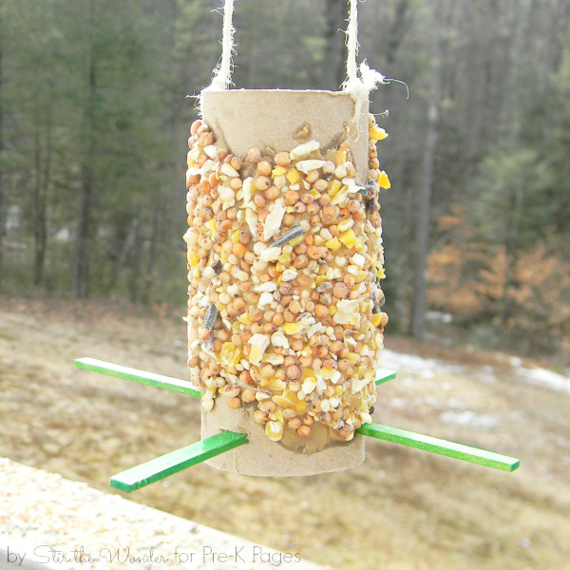 | Science Activity  Can you find out about the life cycle of an animal or insect?  You could choose a chick, a butterfly or a frog.  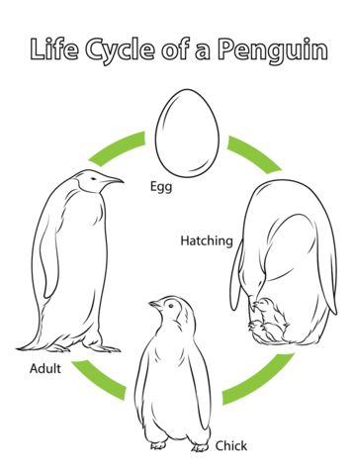  Do you remember when we learnt about the life cycle of a penguin when we looked at Antarctica?
Please see below some ideas for activities you could complete this week. You can present your work in any way you wish. Or if you have any of your own ideas for activities or something you would like to learn about then you can do that instead.

