Money
Here you will find the White Rose Maths pages linked to money (children- you will be used to just having the right-hand side of the page chopped up for you to complete in your books!) please feel free to complete sections as you wish. On the reasoning and problem-solving pages you will see the questions with the answers alongside, the children are used to having these problems as well. I have left the answers on there so they can either self-check or are there for guidance.

Here are a couple of useful websites which may help to start this strand of learning:

https://www.topmarks.co.uk/Interactive.aspx?cat=25
There are lots of games on here that the children may like to experiment with and play to become familiar with money.

https://www.bbc.co.uk/bitesize/topics/zp8dmp3
https://www.bbc.co.uk/bitesize/topics/z8yv4wx/resources/3
Clips to watch to help explain aspects of money. The top link is to the KS1 page which may be a good place to start as a reminder for some children.

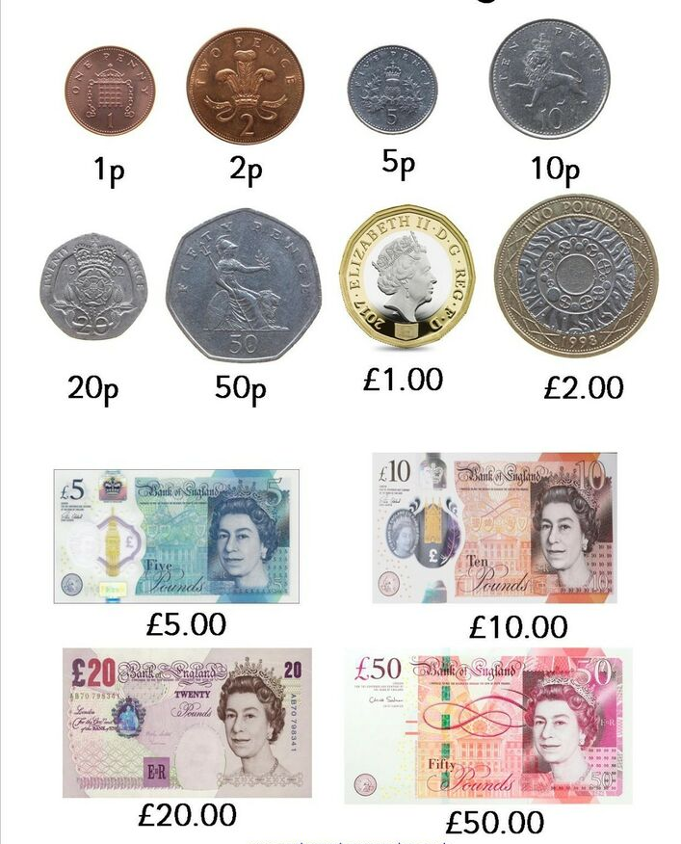
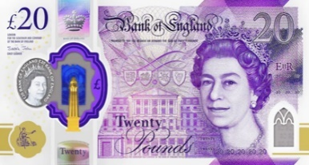
You may like to start off by seeing which coins you have in your money box/purse at home and seeing if you can recognise the value of the coins.

Next, see if you can add up the total of the coins.

Extra challenge….
If we know there are 100 pennies in 1 pound, can you convert how much you have in pounds to pence?
