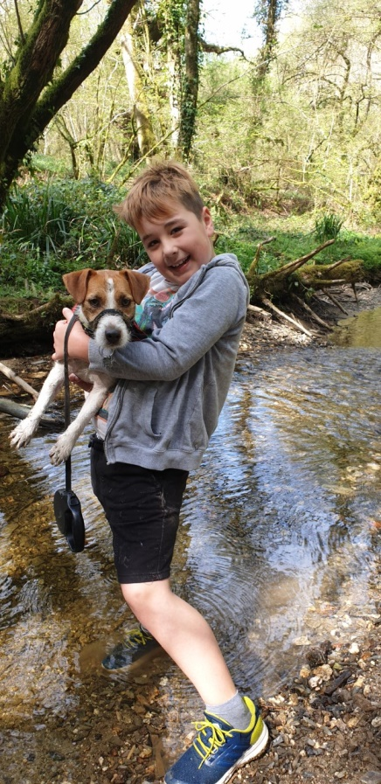

FOREST LEAFS SWAYING

**F**

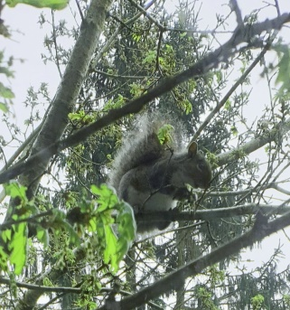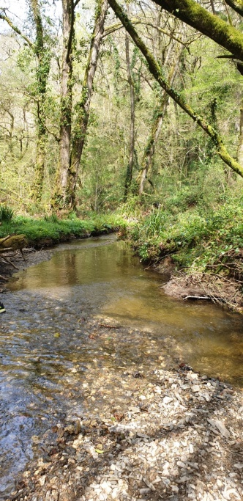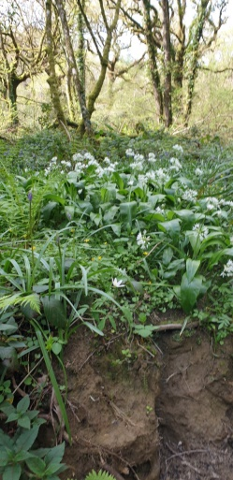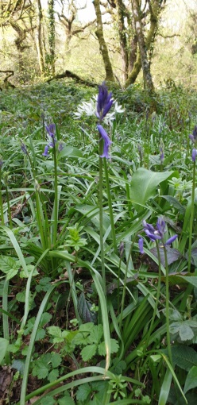

**S**

**E**

SWAYING BRANCHES ABOVE MY HEAD

SINGING BIRDS IN THE TREES

TREE LEAVES TURNING GREEN

WANTING TO CLIMB

KICKING STONES ALONG THE PATH

RIVER RUSHING

**T**

**R**

ANIMALS PLAYING

LEAVES FALLING IN FALL

ENJOYING BEAUTIFUL BLUE BELL COLOURS

WLS HOOOOTING

**S**

**K**

**L**

**A**

**W**

**O**