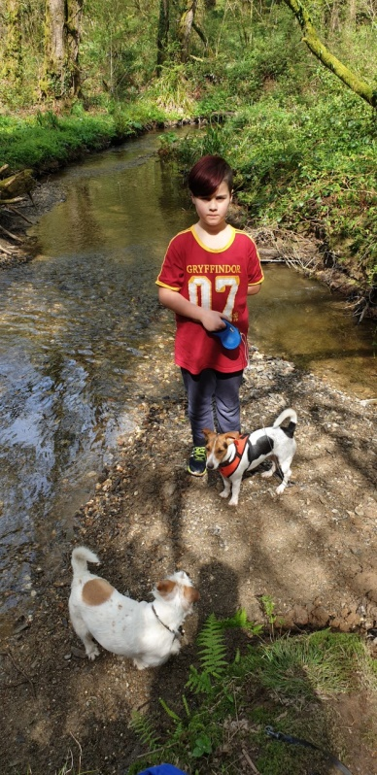

LIES BEING ANNOYING

**F**

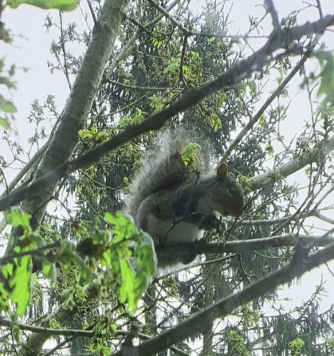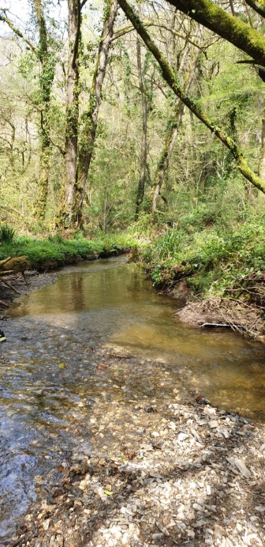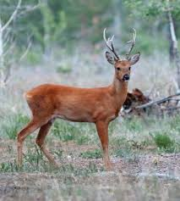

IND RUSSLING LEAVES

REES SWAYING

PLASHING IN THE STREAM

ICKING LEAVES

NIMALS HIDING

EAVES FRESH AND GREEN

IVER WATER SPLASHING

QUIRRELS STUCK IN TREES

NJOYING GETTING WET

WLS SLEEPING

**S**

**K**

**L**

**A**

**W**

**T**

**S**

**E**

**R**

**O**