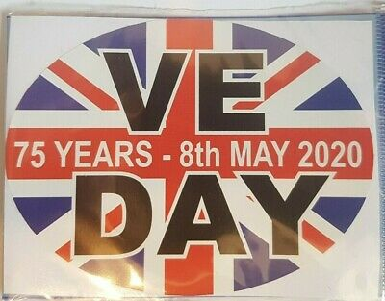

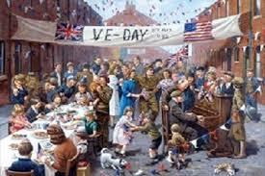
Friday 8th May is the 75th anniversary of VE Day. VE Day is also known as Victory in Europe Day and marks the day towards the end of World War Two when the war ended in Europe on 8th May 1845. To celebrate that the war had ended there were lots of street parties all over the country. People put tables out in the streets, made party food and decorated with bunting and flags.

Celebration activities

On Friday 8th May, many people will be having stay at home street parties and decorating themselves and their homes in red, white and blue to represent the Union Jack.
At 9am on 8th May, The Queen will address the nation and there will be a live stream on BBC – which is the exact same time that her father, King George VI, spoke to the UK 75 years ago, on the actual VE Day.

Below are 6 activities if you would like some ideas to celebrate VE Day; some of them do require a few resources. However, there are lots of other activities out there too so please do pick and choose which ones you would like to do.
If you have any questions please email me: lforbes@pelyntprimary.co.uk

Activity 1
Watch the PowerPoint presentation attached in the blog to find out about VE Day (if you do not have Microsoft PowerPoint there is an information sheet you can use instead on the blog). You can then pick an activity below if you wish.

- Create a poster filled with facts about VE day.
- Write your own fact file using subheadings and paragraphs.
- Role play the first ever VE day. What were you thinking, feeling etc?
- Record yourself pretending to be a news anchor telling Britain the news.
- Write questions about VE day and then quiz your family and friends.
- Research your family tree, are you related to anyone who served in the war? Find out information about them.

Activity 2
Design your own VE Day medal.

Your task is to create a medal for British soldiers who served in the Second World War that is just as symbolic and creative. Your medal can be any shape or size.

You can use paper, clay, salt dough or paper mâché to create the medal.
You can use metallic paint, tin foil, bright sharpies or pens to colour your medal.
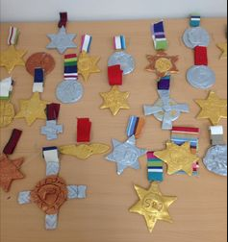
You can use paper, ribbon or card to create the stripes.

Maybe you could even add a photo or drawing of someone who was alive during the war?

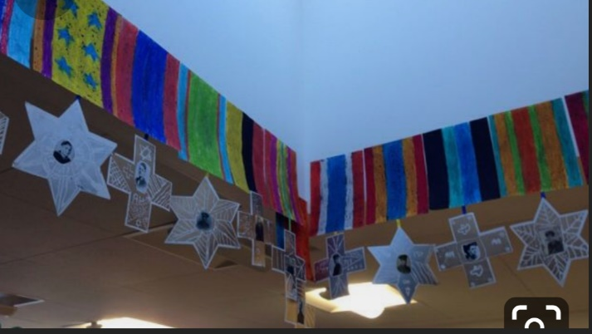
Who would you give your medal to and why?

Activity 3
Phonetic Alphabet
The phonetic alphabet was used in RAF transmissions during the war to send messages. Can you spell your name using the phonetic alphabet?
For example:

Mrs Forbes
mike, romeo, sierra foxtrot, oscar, romeo, bravo, echo, sierra

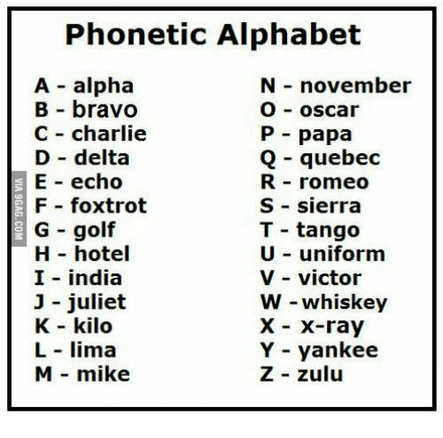

Activity 4
Morse code
Morse code is a way to send messages without using words. They used it during World War 2. The code has its own alphabet made up of short or long sounds or flashes of light.
Your challenge is to:
- Crack the message below. You can write the letters in the boxes below the Morse code.
- Send a message to a parent or sibling using a torch or something that beeps. Have they understood your message?

…. | . | . - .. | . - .. | --- |  | -.-. | .-.. | .- | … | …

..---

Activity 5

Try and learn the Horrible Histories VE Day song and perform it to your family.

https://www.bbc.co.uk/cbbc/watch/horrible-histories-songs-ve-day-song

Activity 6
Plan a celebration to have at home to celebrate VE Day. These could include:
- Create your own red, white and blue bunting (see attached template in blog)
- Make an invitation to invite someone to your party
- Design your own VE Day party hat
- Make a Union Jack flag to wave

- Create a VE Day wreath for your front door.
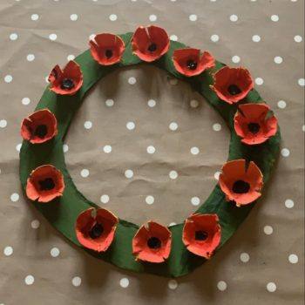
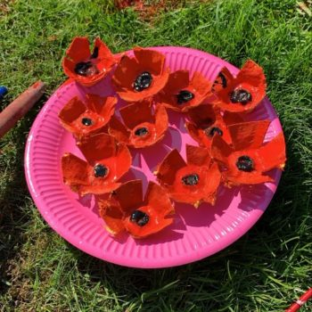

- Have a picnic
- Do some red, white and blue baking

- Try your hand at 1940’s baking - there are lots of recipe ideas online to take you back to the 1940s. Here are a few: Apple Crumble, Bread & Butter Pudding and Oaty Biscuits
- Play some party games

