VE Day ideas Friday 8th May 2020

Here are some ideas of tasks you could complete to develop your knowledge and understanding of VE Day. Remember, it is up to you what you complete so feel free to pick and choose.

1. Create your own speech as if you are Winston Churchill declaring the news (remember
the types of persuasive language that need to go in a speech!)
a. Watch his speech to see what it was like
https://www.youtube.com/watch?v=NEavcsrMoMw
b. Look at persuasive writing techniques https://youtu.be/Mlka2xBvV5Q

2. Create a VE day poem or an acrostic poem

3. Make a PowerPoint about the 75th VE Day and why it is special

4. Design your own VE Day medal (see document uploads)

5. Design and make your own Spitfire. You could make it out of paper, wood, recycled materials etc. Test out your design. How far does it glide?
Does the material used for a paper plane affect the distance it travels? Try using newspaper, card, tin foil etc and test it! Remember, only change ONE thing to make it a fair test. Record your results.

6. Plan a celebration to have at home. Think about what you could do to prepare for it:
* Write invitations to invite your family members
* Design a menu
* Create some posters
* Create a playlist of music (1940s songs)
* Make some bunting
* Design a game to be played
* Make decorations to put up (ask an adult before sticking anything to the walls!!)
* Learn a dance such as the Lindy hop swing
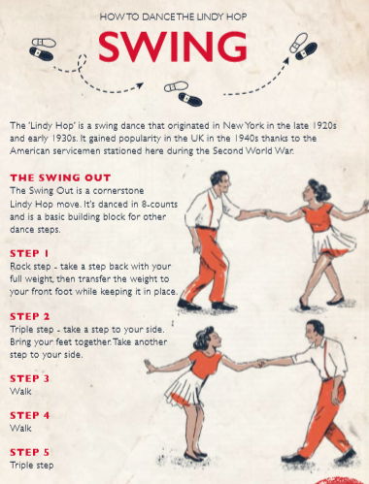

*Make some traditional war time dishes (these are just a few taken from the English Heritage website)
