Maths 04/05/2020
This week our focus is on angles. You might need to research some of the terminology if you have forgotten! You will not need a protractor, as you will not be measuring angles. Instead, you will be calculating the size of the angle using facts you are told about the line or shape.
This week I have uploaded the following worksheets,
- Types of angles
- Angles on a straight line
- Angles around a point
- Angles in triangles
Below I have included some help sheets and some practical and other ideas, along with some interactive games I have found based on angles. I am only an email away if anything is too tricky or for you to send pictures of your work : )
Interactive games
https://www.mathplayground.com/alienangles.html
https://www.topmarks.co.uk/Flash.aspx?a=activity16
https://mathsframe.co.uk/en/resources/resource/470/Angle-Alien-Attack
https://www.topmarks.co.uk/Search.aspx?q=angles
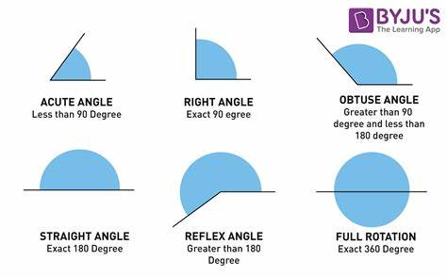
Help and
Key things to remember:

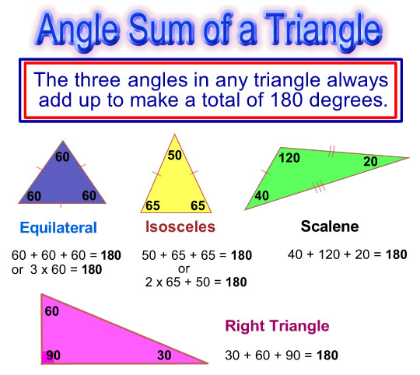

X and y angles on this triangle example must = 180 ˚ together as it is on a straight line.
I know angles in a triangle = 180˚ so I do 180- 62 – 51 = y.
Then 180 – y = x

Practical and other ideas
Find sticks and layout the different types of angles or triangles.
Draw or create some angles and quiz someone on what type of angle they are (you will need to know the answers!)
Have an angle hunt finding different angles around your house and/or garden. Think about what type of angles they are.
Practice jumping in half and full turns. Can you jump 2 full turns? Cam you work out what 2 full turns would equal in degrees?
Make angle questions for other family members.
Create a piece of artwork using different types of triangles and angles- try and use all types of angles and all types of triangles. You might like to do this in the style of Kandinsky (who we have been basing our artwork on in class).
Look at (and draw if you like) a tree which you can see. Look at (and label) the angles of the branches. Estimate if the angles are acute, obtuse or reflex angles.
I am sure you can think of lots of other interesting ways to learn about angles?! Surprise me with an idea via email : )

