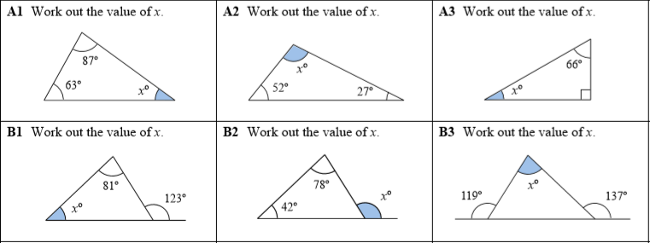
Try to work out ‘x’ for each of the questions. Remember that straight lines (half turns) and internal angles in a triangle add up to 180.
Example for A questions: I know angles in a triangle = 180˚ so 180 – 70 – 45 must leave me with my missing angle.
Or 180 – (70+45) = x
You need to remember to use a method for these (column would be good)

Example for B questions: I know that angles on a straight line = 180˚ so to work out x I need to do 180 – 120 = 60. Therefore x = 60
Then to work out Y I have to do the same as A questions because now I know 2 internal angle measurements. So I do 180 – 70 – 60 = y
Or 180 – ( 70+ 60) = y

