Character descriptions
Read the text and try to find as many adjectives that describe the characters as possible.

Dink
Deep inside the darkest cave lived a hideous creature known as Dink. Covered from head to toe in grotesque white pimples and crusty mud soaked skin, you can smell Dink before you can EVEN see him. On the very top of his head, lives a family of lice that play all day in his bright green, soiled hair. His enormous muscles escape from his tiny clothes, which are grungy brown from years of unwashed sweat. Not only is Dink disgusting, he also has a terrible attitude. He hates everyone; he would not think twice about devouring you if you ever disturbed him. Neither running nor hiding would save you from his gruesome beast.
Veins pop out from Dink’s greasy elephant like hands. His thumbs always clench a large, old, wooden bat for when intruders disturb him.

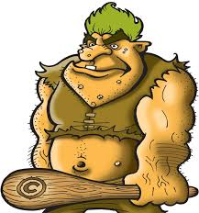

Annabella
In a secluded part of town, lived a remarkable young lady. Annabella. Her thick, glossy auburn hair tumbled down her shoulders in waves, which bounced carelessly whenever she moved. When in public, Annabella, always wore a bright, crimson dress that glistened bravely in the light and long, silk, pink gloves on her slender hands. However not all was as it seemed. Annabella wore this dress as a distraction- she was actually a devastatingly shy girl that blushed when walking into any room. Surprisingly though, she was an expert in all things martial arts. Annabella’s parents, who are both deceased now, were adamant that Annabella be able to defend herself so when she was ten they enrolled her in every defence class possible. Throughout her teenage years, Annabella’s thin, skinny appearance transformed into a much more lean, muscular and strong one. Now, when Annabella leaves her house, her crimson dress concealed the fact that she was ready for any danger.

