Our VE Day Celebration
8th May 2020

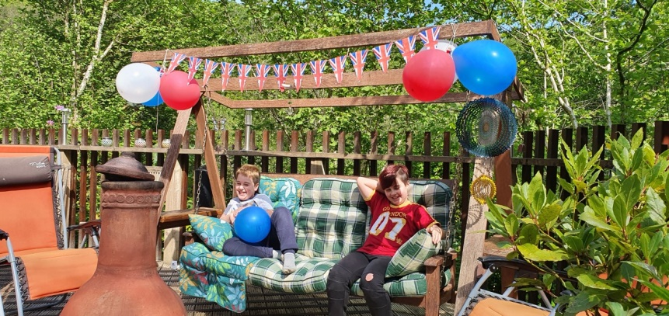
We have had great fun researching the topic of VE day and decided to hold our own party to celebrate…
We made decorations for our garden….
We designed a menu, and made
VE day stones to add to the Deerpark
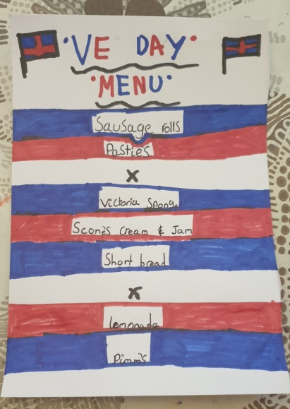
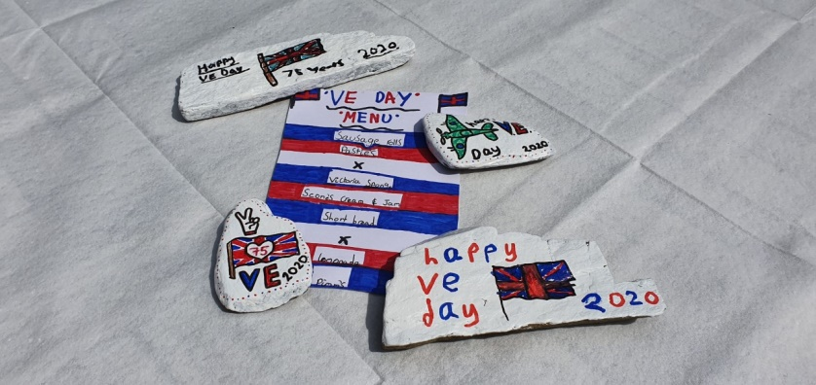
rocks collection….

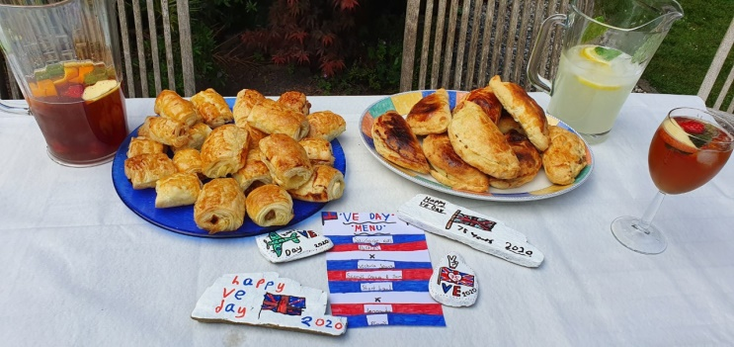
We made lovely traditional sausage rolls & pasties…
Victoria sponge, scones with cream & jam, shortbread, and of course.. a big trifle!

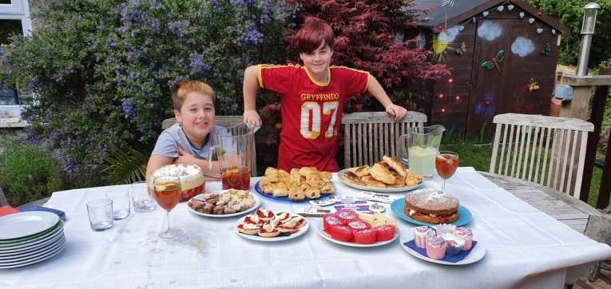

Homemade lemonade was lovely, as was the Pimms ;) !! 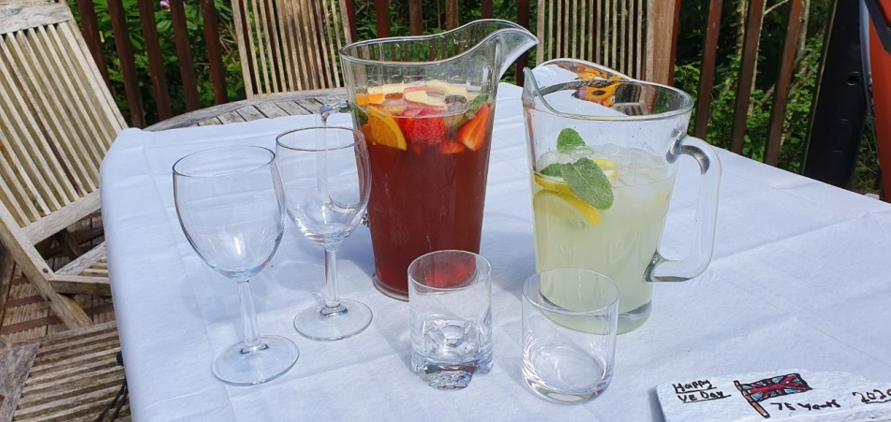
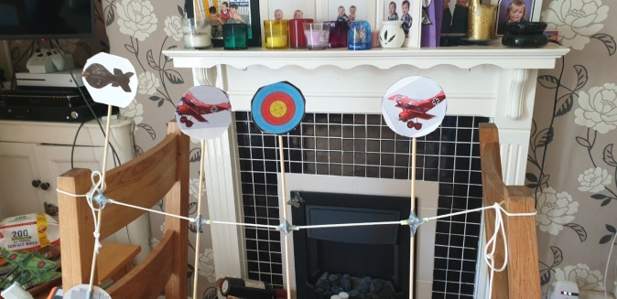
We made some games to play…
shoot the German targets,
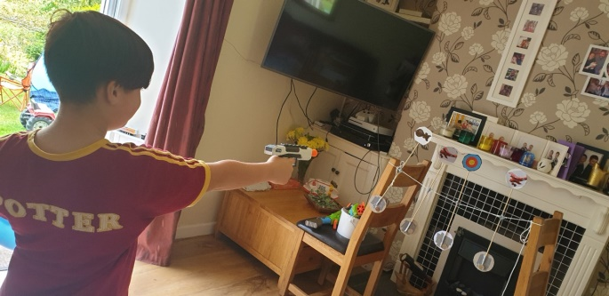
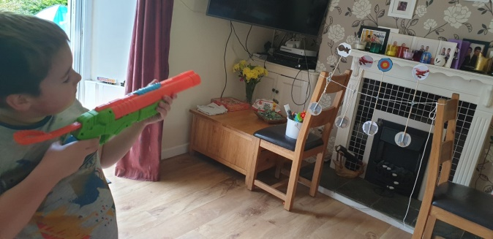

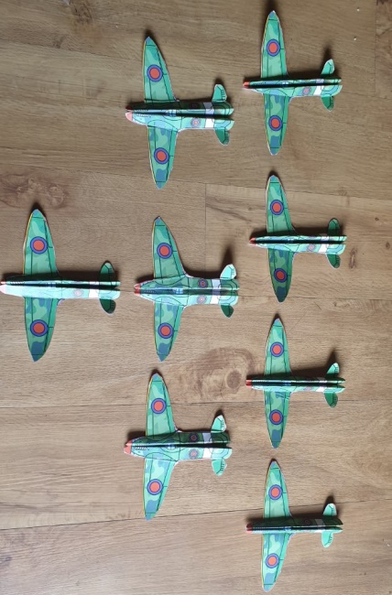
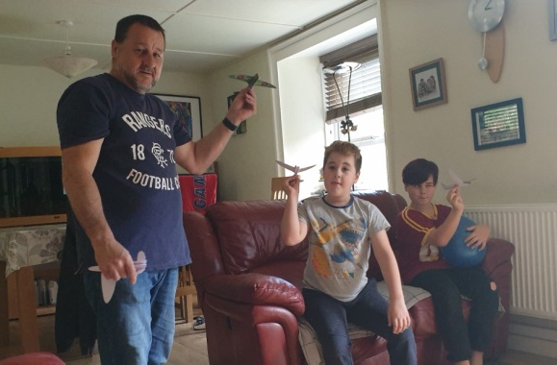
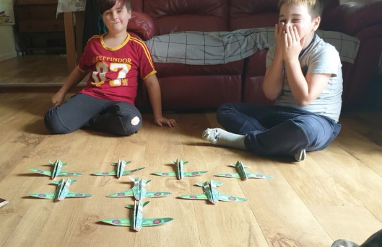
And how far can your spitfire plane fly?...

All we missed were friends and family to share it with
but we have decided to throw a corona party when our own celebrations for surviving our current world crisis can be had!!

