Hippo Has a Hat by Julia Donaldson Class 1 Home Learning Week beg 11/05/2020
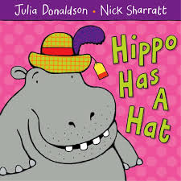  First, watch the video of Mrs Wakeham reading the story of Hippo Has a Hat by Julia Donaldson, then choose as many of these activities as you like: | Alliteration: alliteration is when words begin with the same sound in a sentence – remember when we used it to give ourselves pirate names? I would like you to spot the alliteration as I read the story and tell a grown up or write the words. I will start you off – Hippo has a hat, a cardigan for cat. See how many examples you can find and let me know.
Speak/write a sentence a day.  Play questions and answers; the rule is that you must use perfect sentences to ask/answer questions about the book. Then use your sound mats to sound out to write down one of the sentences every day. A grown up may ask, ‘What are you wearing?’ and you might answer, ‘I am wearing a red shirt.’ Or, ‘What is the pig wearing?’ answered with ‘The pig is wearing jeans.’ I would like you to write your answer as a sentence, starting with a capital letter, leaving finger spaces between each word and ending with a full stop. Check that it makes sense too | Pencil control/ design activity: use the activity sheet from the blog to design your own clothes for the animals to wear at their party. Use your best pencil control to colour the whole picture and send it to Mrs W.  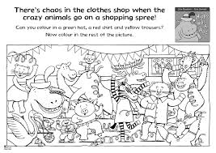
Rhyming activities: Find the rhyming words in the story. Can you make a rhyming string from each pair like you did last week? When you have done that, play with the words – can you use them to change the rhyming words to make a nonsense version of the story with a grown up? You could ask a grown up to record you telling me your new sentences. Have fun playing with words | Use your sound mats to sound out the words to complete the crosswords; there are two to choose from on the blog - animals or clothes. Use the pictures to help you.  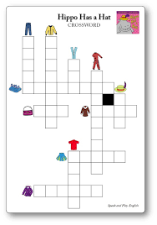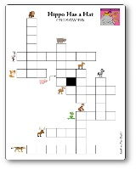
Maths: draw pictures from the story to show how you can make the number 14 – will you draw 10 hats + 4 coats = 14 items altogether? Or you could draw animals, party clothes, party decorations, anything really! See if you can write number sentences to match your drawings. | 