Setting description plan

Nouns

Adjectives

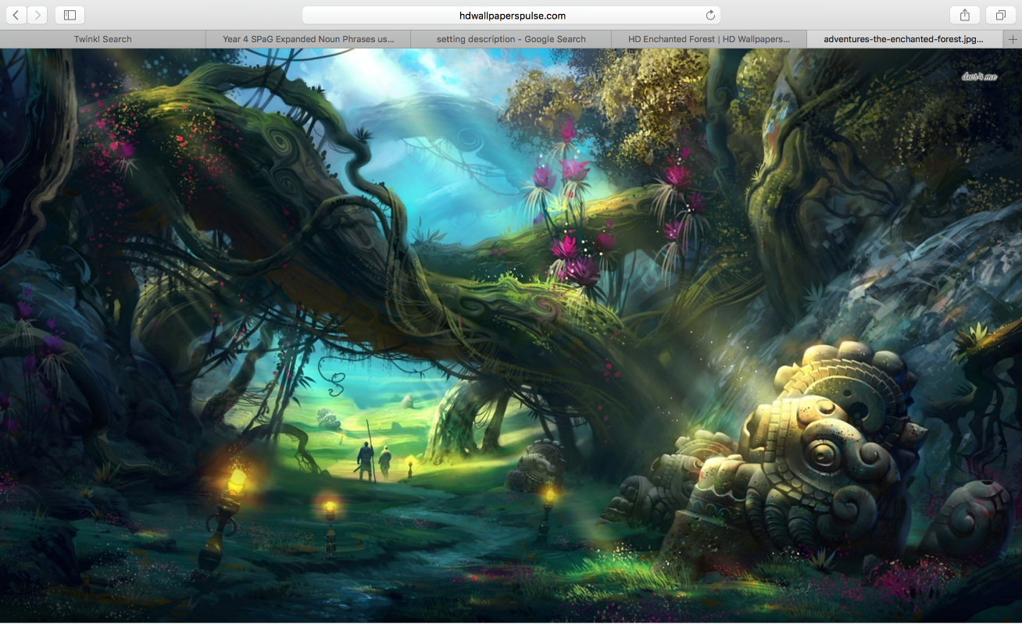

Or draw your own setting

Interesting similes or other figurative language

Senses (see/hear/smell/touch/taste)