Class 3 English – Week 7 Week Commencing 18th May 2020
Pelynt Academy
Summer Lane
Looe
Cornwall
PL13 2LG
Saturday 16th May 2020

Dear Class 3
You have been trying so hard with your learning at home since the beginning of lockdown, well done. Lots of people are feeling fed up and are missing their friends and family.
I thought this week you might like to write something a bit different and write a letter to somebody to tell them what you have been doing and maybe help to cheer them up.
You may have written letters to people before and you may have received letters. Before we had phones, text messages and emails, writing letters was the main way of communicating with people who weren’t nearby.
Most people love to receive letters (I know I do) especially if it is not a bill! So, this week I want you to have a go at spreading some happiness by writing a letter to somebody of your choice.
Letter writing is such a useful skill to have and recently you all wrote a brilliant persuasive letter to the Roman army, so I hope you can remember the key features and skills you learnt! I wonder who you will choose to write to?
Happy learning!
Yours sincerely
Mrs Horn
Have a look at the letter format below to remind yourself of the layout. You may have some letters at home that you could look at too.
We always start a letter with the word Dear even if we don’t know the person we are writing to.
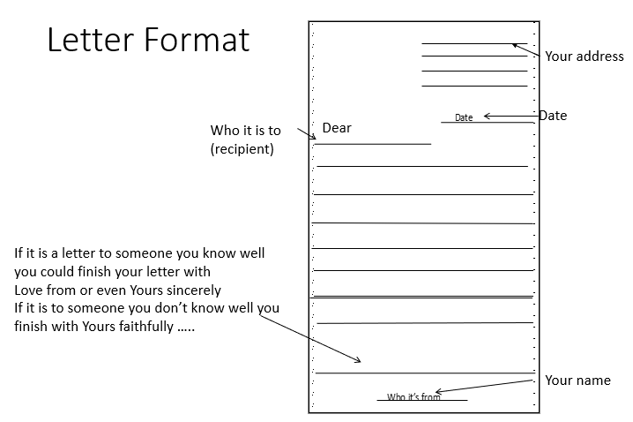

Now have a think about who you would like to write your letter to.

It could be someone in your family that you can’t see at the moment
E.g. Your Grandparents Your cousins Your friends

It could be Your teacher (I would love to receive a letter from you!)

It could be someone famous that you would like to hear from
E.g. Your favourite sport or pop star
the Queen an artist
Sir David Attenborough Boris Johnson
An author

It could be someone you would like to thank
E.g. the doctors and nurses at a hospital a key worker a carer

Choose the person that you would like to write to. Jot down some notes of what you might include.

E.g. What you have been doing – exercise, schoolwork, hobbies, games, TV
How you are feeling - use some exciting adjectives to describe your feelings
Some questions you would like to ask - Remember question marks
Some information about your family - What they are doing, e.g. working, looking after you

Now start to write your first draft.
*Remember to make it interesting for your reader. Try to use interesting and exciting vocabulary and write in sentences and paragraphs.
*Make sure you use your phonics to help you sound out the words if you are unsure. Think about the resources you could use to help you such as a dictionary, thesaurus, spelling word mat, spellings in homework books.
*Once you have finished writing, read it through and check your sentences make sense, check your spellings and check you have used correct punctuation (maybe you could ask an adult to check it with you if they are able to)
*Edit and improve your letter – how could you improve it? Could you up level some of your words to improve your vocabulary? Use a range of conjunctions to extend your sentences, make sure you have adjectives in your writing and a good level of detail.
*Once you have edited and improved your letter and are happy with it, copy it out neatly in your best handwriting using the correct letter format.
*You might also want to illustrate it to make it look bright and colourful.

Now you need to send your letter.
You will need an envelope to put it in and then you will need to find out the address of the person you are sending it to.
You will need to address the envelope correctly too, using the proper format and then stick on a stamp.
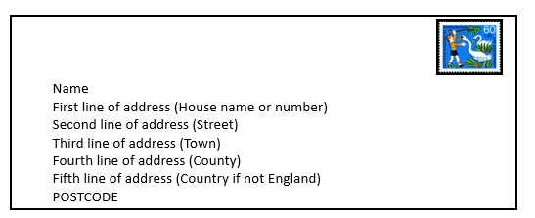
Now you will need to go to the post box or post office with an adult to post your letter.

Well Done! Hopefully you have enjoyed writing your letter and you have learnt some good letter writing skills. I hope you managed to find the address, an envelope and a stamp and have posted your letter.
I hope you will get a reply and have the pleasure of receiving a letter. It is a lovely feeling!
Stay safe and keep well.
Mrs Horn

