Ten Tall Giraffes by Brian Moses Class 1 Home Learning Week beg 18/05/2020
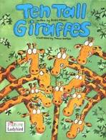  First, watch the video on the class blog of Mrs Wakeham reading the story of Ten Tall Giraffes by Brian Moses, then choose as many of these activities as you like: | Teens Numbers Challenge: we have been learning that teens numbers are 10 and some more. Please use the numbers from each page of Ten Tall Giraffes and add 10 to each to make a teens number. Write down each number. What happens when you add 10 and 10? Is the answer a teens number? You may like to write a number sentence for each: 10+10=? 10+9=? 10+8=? 10+7=? 10+6=? 10+5=? 10+4=? 10+3=? 10+2=? 10+1=?
Make a book.  I would like you to make your own version of this counting book. Can you choose different animals? Use your own ideas to make them do different things. Can you make your own words rhyme? I would really like you to start with our number of the week – 15 and draw the correct number of whichever animals you choose on each page. When you are writing remember to begin your sentences with a capital letter, leaving finger spaces between each word and ending with a full stop. Check that it makes sense too | Art activity: choose one of the animals to create a collage of. Which different materials will you use? You could use pasta, rice, lentils, fabric, junk, coloured scraps of card/paper, natural materials, fabric, newspaper, anything at all!  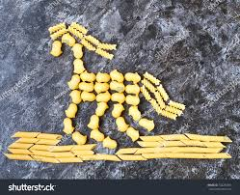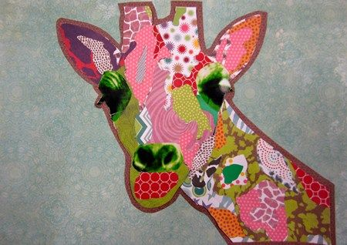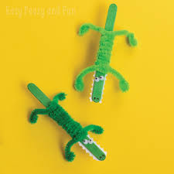  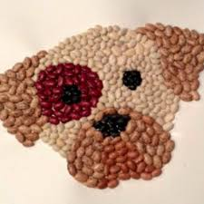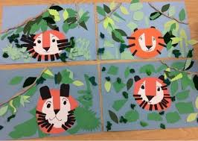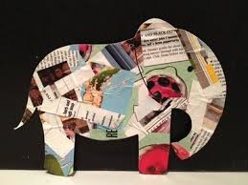
Create an animal fact file: Choose one of the animals from the book and with a grown-up use non-fiction books and/or a computer to research some facts about that animal. Use the template attached to this blog to write a fact file and tell me what you discover. Remember the sentence rules above and don’t forget Smartie the Penguin’s rules for using the internet.
Maths: draw spots on two giraffes to show how you can make the number 15 altogether– will you draw 10 on one giraffe plus 5 on the other to equal 15? Or 9 + 6 =15? Explore how many number pairs you can find to make 15. Can you write number sentences to match your giraffes? Maybe you could do the same for other teens numbers. There is a giraffe template attached to the blog. | Communication and Language - can you think of any nursery rhymes or songs which include any of the animals from this story? Ask a grown up to help you learn some. I would love to hear recordings of you singing an animal rhyme or song.
Don’t forget to send pictures to show Mrs Wakeham what you have been learning this week:
jwakeham@pelyntprimary.co.uk

