Phonics Rainbow Challenge
Can you create a rainbow like Mrs Wakeham’s using the Phase 3 and 4 tricky words? If you think you need to practice Phase 2 include them as well. You can then use your rainbow to practice reading the words to a grown up.
Phase 2 words | Phase 3 Words | Phase 4 words
I  no  go  into  the | he all  she my  we are  me her  be they  was you | there have  like so  do some  come were  little one  when out
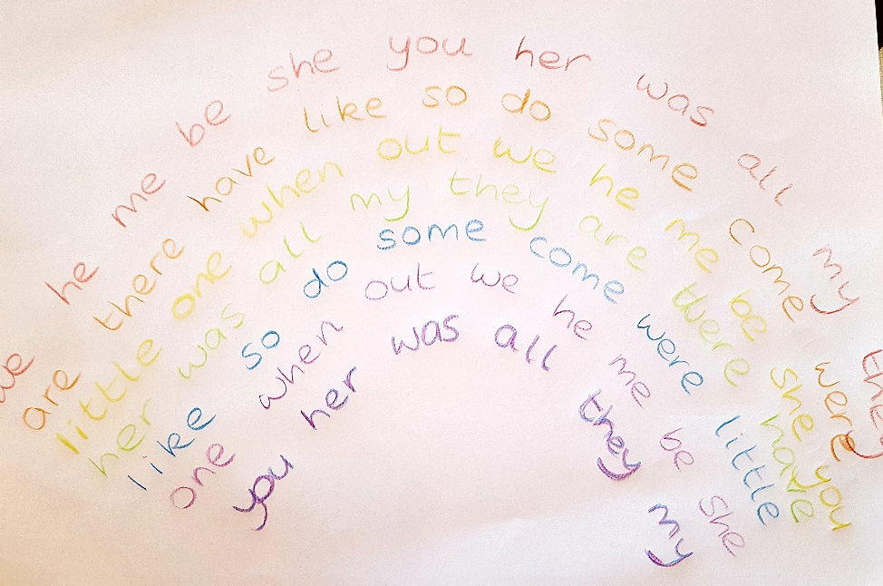

Be creative – you might use felt tips, pencils, paint or crayons. You might also add clouds and a sky! However you choose to set out your rainbow, make sure that you and others can read the words.
Have fun!

