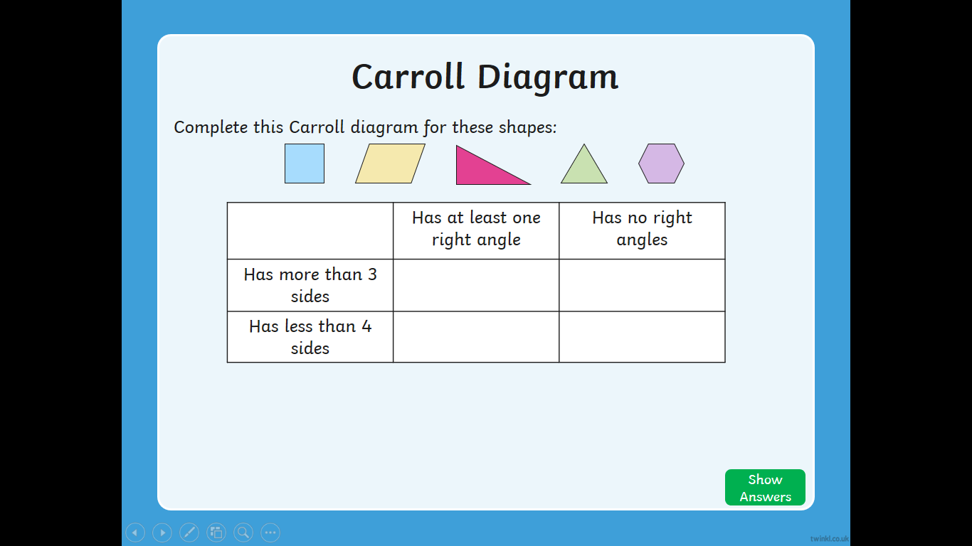

Try to sort these 2d shapes using the Carroll Diagram. You have to read the statements and work out which box you could place the shape in for it to be accurate.

Where could an isosceles triangle go?

Can you draw your own Carroll Diagram with different statements?

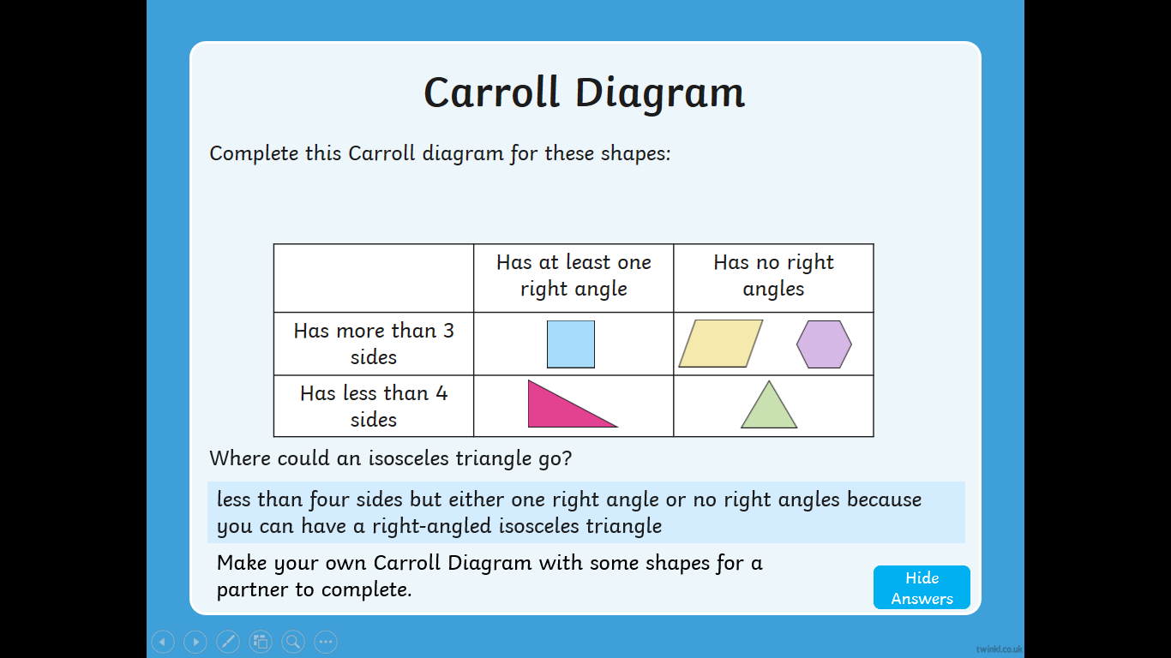

Answers

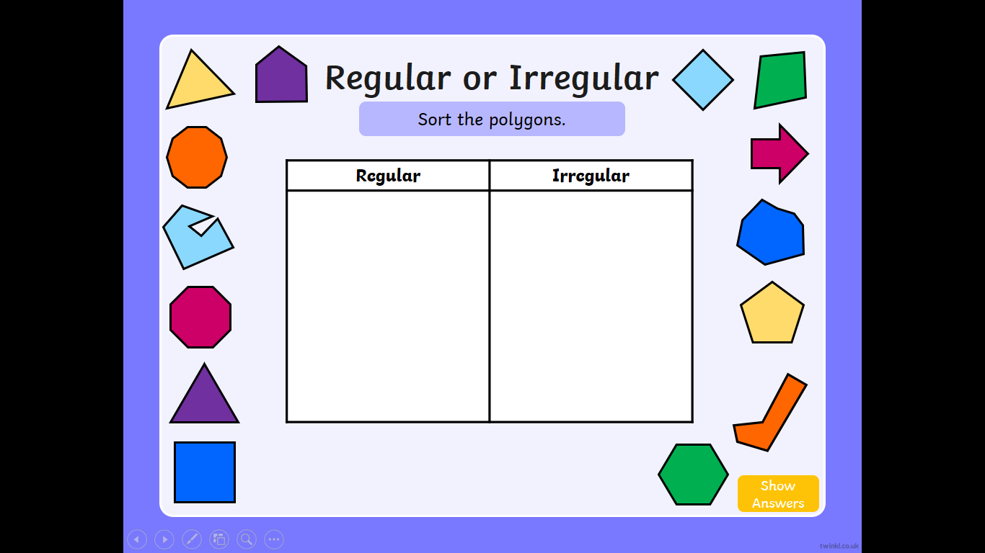

Try to sort the shapes into regular and irregular polygons

2. Try to explain what a regular polygon is, compared to an irregular polygon.

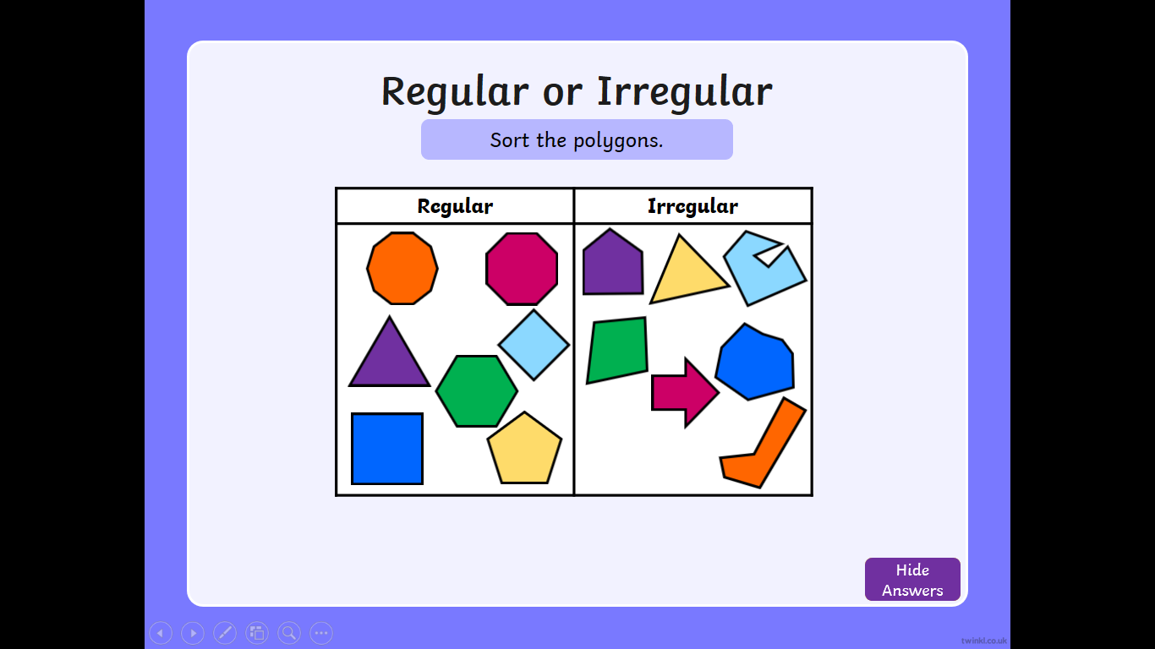

Answers. Did you sort them correctly? Does this change your explanation?