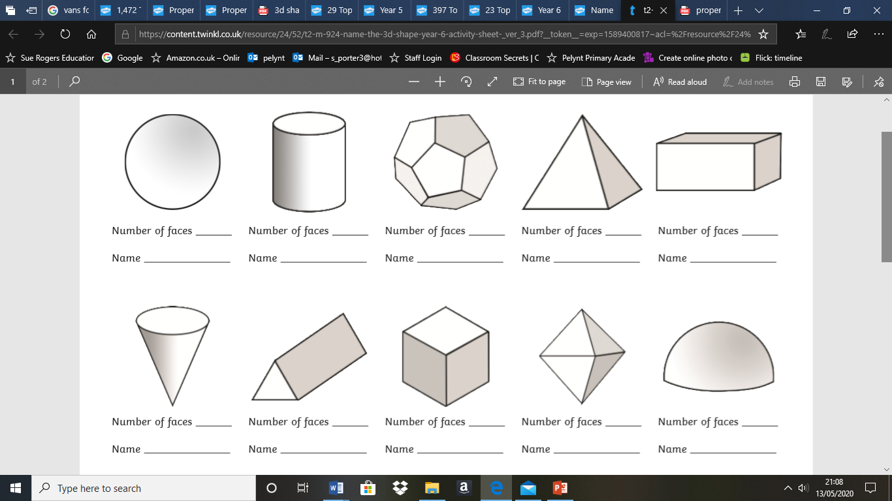

Try to write the number of faces of these 3d shapes. Don’t forget the faces that you can’t see! Then write the names of the shapes.

If you don’t know some, have a ‘guess’, then use the internet to research their names. Finally use the answer sheet (on page 2) to check your research!

Can you find any of these shapes around your home? Write the object that you found below the shape name. E.g. Cereal box under cuboid.

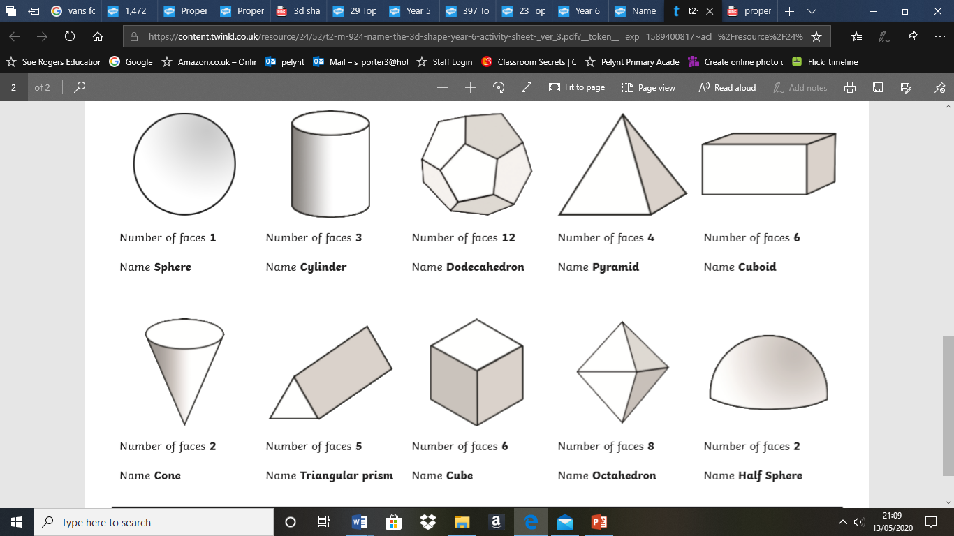

Answers