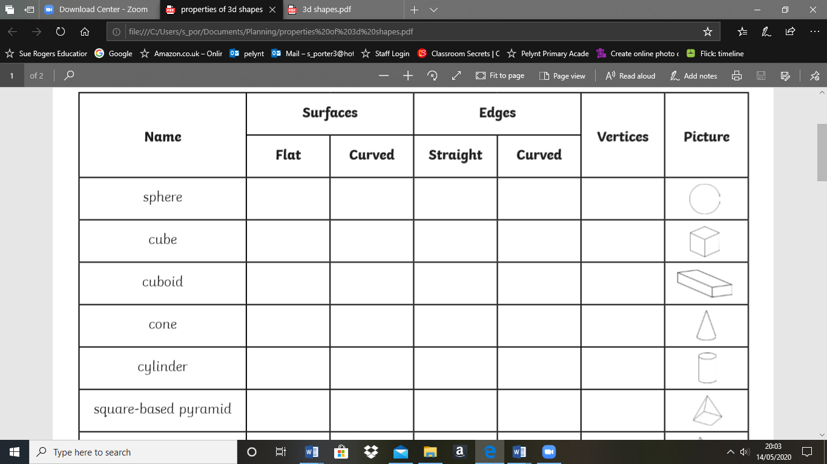

3d shapes are ones you can pick up. They have faces (sides), edges and vertices (corners). Complete the table below, identifying the properties of each 3d shape has.

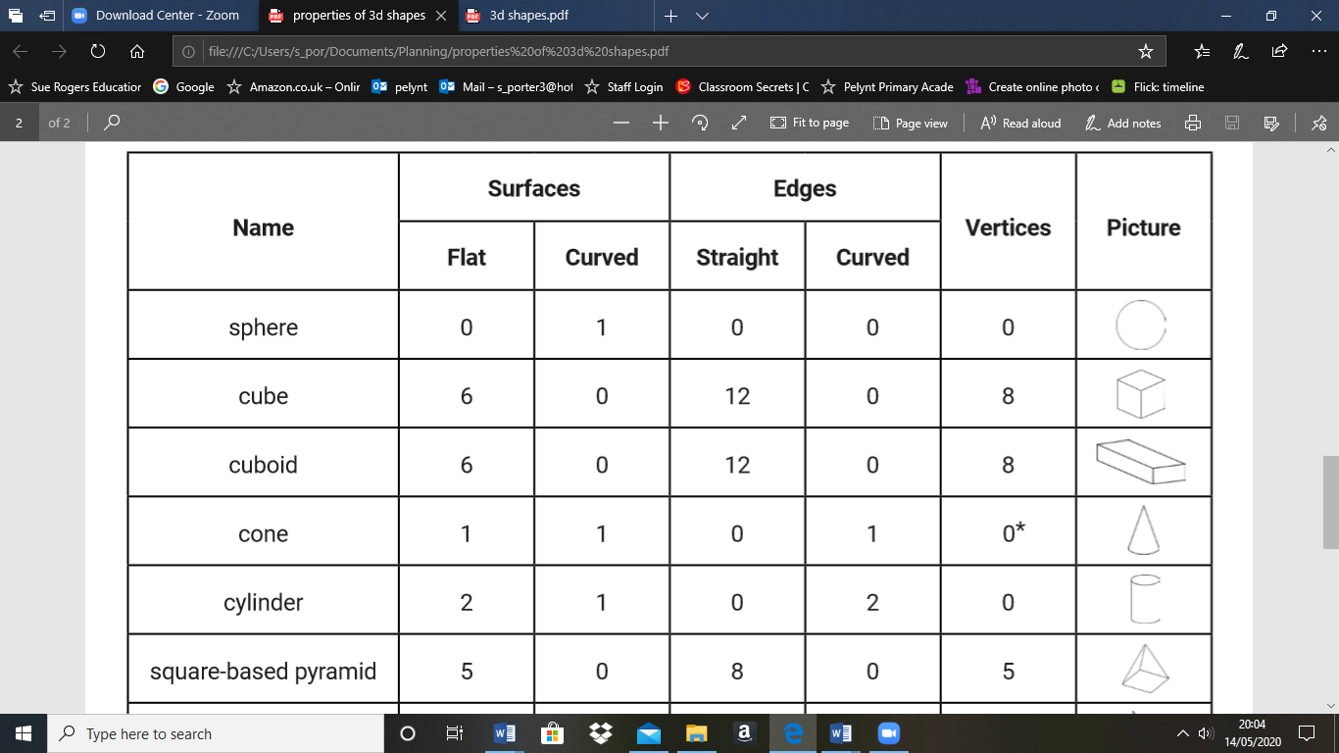

Answers

Try to sort these 3d shapes using the Venn diagram

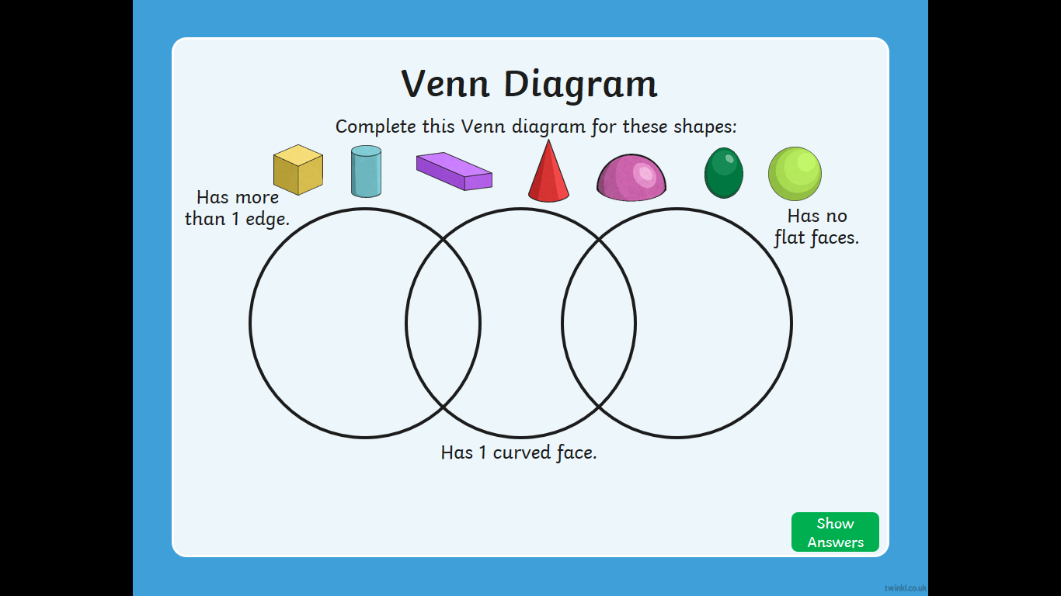

Can you describe a shape that could only go in the, ‘Has no flat faces’.

A shape with no flat faces could be a…………………………….

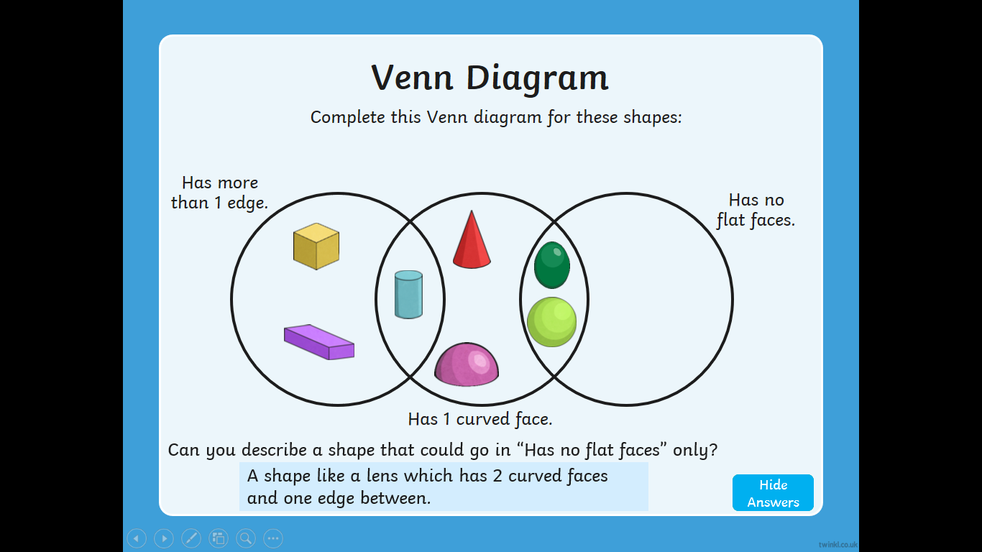

Answers