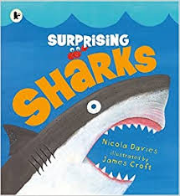
Watch the story being read and then see if you can answer these questions: https://www.youtube.com/watch?v=JwkKDzdGXOo
Shark Quiz
- Which is the smallest shark in the world?
- Which shark has built in fairy lights?
- Why does an Australian Shark have a patterned skin?
- What do Saw Sharks use to seek their prey?
- Which two sharks sound and look like they come from a monster’s tool kit?
- What is special about a shark’s tail fins?
- What is special about a shark’s jaws?
- How many teeth can a shark have at once?
- What can baby sharks do as soon as they are born?
10.What are Dog Fish eggs called?
11. Where are a shark’s eyes?
12. How does a shark know where to bite, to catch its prey?
13. Why do you think this book is called ‘Surprising Sharks’?

