Hello Class 2,
I hope you have had a lovely half-term break and have been enjoying the glorious sunshine. I have loved seeing all the wonderful activities you have been doing during our home learning and am very proud of how hard you have been working on the ideas I have given you, and also with some activities you have come up with your families. For out first week back I have put some fun practical activities below if you would like to have a go. It is also ‘Butterfly Education and Awareness Day’ on 6th June so I’ve added some activities all about butterflies. As always if you would like to send me some photos please email lforbes@pelyntprimary.co.uk. Have fun!

Experiment 1  Which chocolate melts the quickest?  Place some white chocolate buttons and some milk chocolate buttons on a plate and leave them in the sunshine.  Which one do you think will melt first? Is there other chocolate you could test? Can you solidify the chocolate so you can eat it? | Experiment 2  Keeping cold drinks cold  Which cup is best at keeping your cold drink cold during this sunny weather? A glass, a mug or a plastic cup?  Place an ice cube in your drink and see which ones stay frozen the longest. What other cups could you test? | World’s Tallest Tower  In 2020 the new world’s largest tower will be the Jeddah Tower, in Saudi Arabia. It will have 200 floors and will reach 1008 meters high.  Use scrap paper and junk materials (look in your recycling) to build a tower. You might like to search for photos of the Jeddah Tower to help you with your design.  What is the tallest building you can build? | Cosmic Yoga  Take part in a fun relaxing yoga session. There are lots of different stories and themes to choose from.  https://www.youtube.com/user/CosmicKidsYoga/videos
Butterfly craft  Below are lots of ideas to create a beautiful butterfly. | Butterfly Symmetry  Please see sheet attached in the blog.  Remember a line of symmetry is a mirror image. It is when an object looks the exact same on one side as the other. | How to draw a butterfly  Follow the 6 steps to draw a butterfly. | Make a butterfly feeding table  If you have the resources you could have a go at building a butterfly feeding table. You will need adult supervision with this.

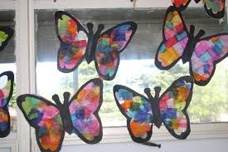
Butterfly Craft
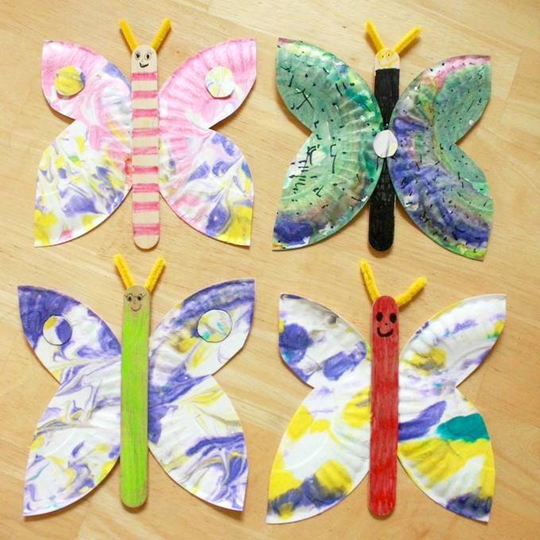
Stained glass butterflies using tissue paper

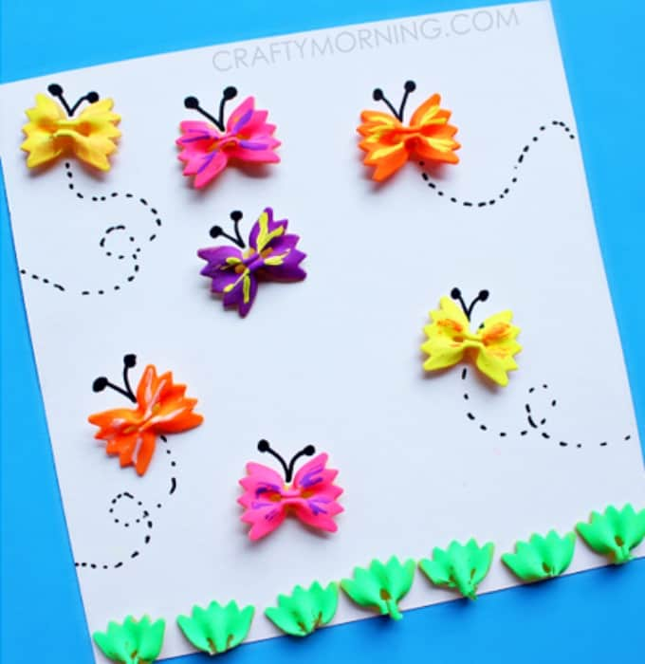

Paper plate butterflies

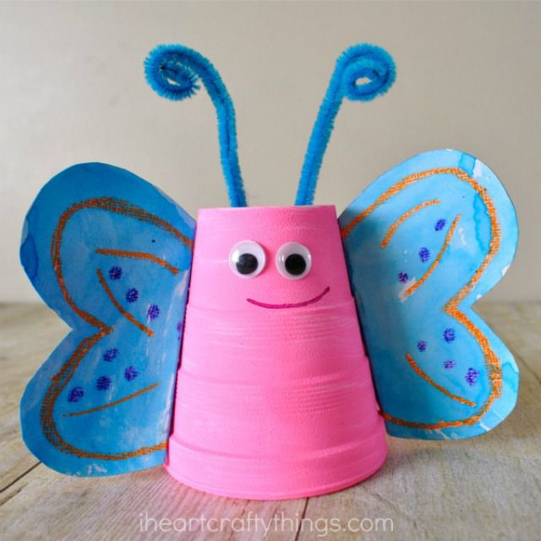
Paper cup butterflies
Pasta butterflies
