Complete a data collection of litter you see when you go to the beach. You could collect the data using a tally chart and record what material it is e.g. plastic, rubber, metal etc. Then see if you can present the data in a chart of your choice. | Research endangered sea animals and then create a fact file about an animal of your choice. | Design a new recycling logo. Think about what you would want it to look like and why. Sketch and colour your design and write a short explanation. | Listen to the story ‘All the Way to the Ocean’ (it is American but the message is the same!) and consider what it is telling you. Think about how you can have an impact on reducing waste entering the sea. Here is the link:  https://www.youtube.com/watch?v=sZW2ByM623g
Watch the ‘What is plastic pollution?’ video and design a poster explaining the importance of recycling and how people can use less single use plastic. Don’t forget to include some interesting facts!  Here is the link:  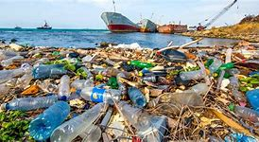  https://www.youtube.com/watch?v=ODni_Bey154  Using the uploaded sheet label the world map with the continents and oceans. | 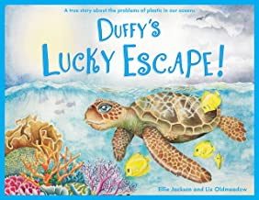  I know you have all heard the story about Duffy in school, some of you may even be lucky enough to have a copy of the book at home. Write a book review about Ellie Jackson’s book or write an alternative blurb for the book. | 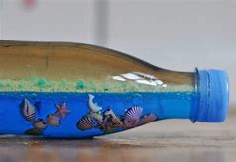  Create your own ocean in a bottle (there are instructions online if needed) or create an ocean habitat using a box.  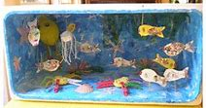 | Create your own poem/song about the ocean. You could write an acrostic poem, a free verse poem etc or create a song and make some music to accompany it.  Complete the ‘Layers of the Ocean’ reading comprehension (in document uploads) Choose your level of challenge, beginning at 1* up to 3 stars.  Make a ‘Save the Ocean’ poster. Consider the important messages you need to include.
See if you can learn the dance to ‘Under the Sea’. Then you could make up your own dance and find some music to go with it. Here is a link to Disney Just Dance:  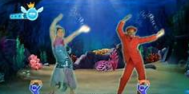  https://www.youtube.com/watch?v=SH-7A3NVQbY | Create a piece of art of your choice using any materials you have to hand. You could make a picture using sand and paint, use crayons and watercolours, make a collage etc. It can be of anything you like e.g. an ocean scene, sea animals. | 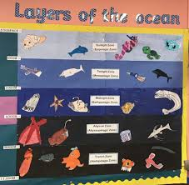  Research the layers of the ocean and create a poster to show each layer with the animals and their habitats. | 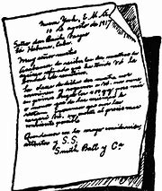  Write a persuasive letter to your local MP about pollution in the ocean and how it must be stopped. Think about what needs to happen and why? Remember you need to convince them to make changes.

