Math 01/06/2020
This week in maths we will be focusing on co-ordinates. We will firstly look at co-ordinates in the first quadrant and then move on to four quadrants. If you have forgotten how to read or plot co-ordinates the key thing is to remember it is X then y (x,y)- with x being the horizontal axis and y being the vertical axis. Use the links towards the bottom of the age to help.
This week I have uploaded the following worksheets:
- Writing co-ordinates 1 quadrant
- Shape plotting co-ordinates 1 quadrant
- 4-quadrant poster- read
- Plotting co-ordinates 4 quadrants
- Use the blank 4 quadrant page to plot your micro journey (from English) on like a map.
Take your 5 stops and list the coordinates of these places.
For example, Stop 1 = Bulky Boulder B and B (-3, 5)

Below and on the other pages, I have included some important help information and I have put some links to learning clips to help with learning about co-ordinates this week. I have also included an online game link. I am only an email away if anything isn’t quite clear enough or for you to send pictures of your work : )
Help
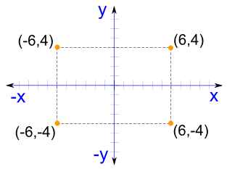
The negative signs are important as it tells you which quadrant you are working in

Links to help:
https://www.bbc.co.uk/bitesize/topics/zgthvcw

https://www.bbc.co.uk/bitesize/topics/zgthvcw/articles/z96k9qt

Game link
https://www.topmarks.co.uk/Search.aspx?q=coordinates

