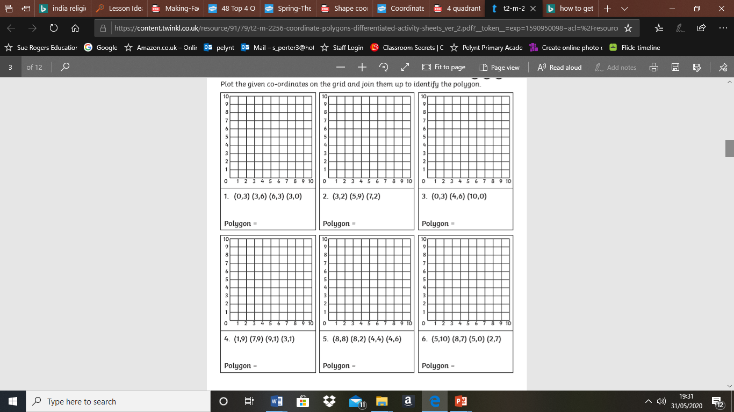

Plot the co-ordinates. Don’t forget (2,5) would be 2 along the bottom, 5 up the side.

