World Ocean Day – Monday 8th June 2020 Class 1 Home Learning Week beg 08/06/2020
First, dress in blue, which is the dress code for celebrating World Ocean Day on Monday 8th June 2020.  Then log into World Ocean Day with a grown up and choose your activities for the day/week: https://worldoceanday.school/  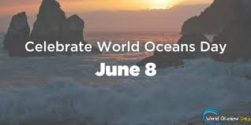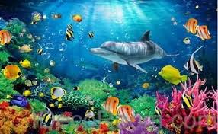 | Design and make your own kite: After listening to the story of ‘Somebody Swallowed Stanley’, challenge yourself to make your own kite, using recycled materials which should not enter the sea and cause harm to sea creatures. Which materials will you use? What shape will your kite be? What will you need to use to make it fly? Then test it. You could use the attached design sheet to record your ideas and then follow the instructions which are also attached to the blog. Remember it must be made from recycled materials. Good luck!  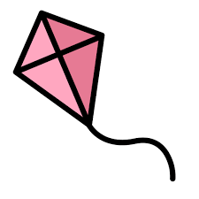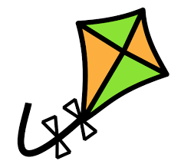
On Monday, at 9.00am, Physical activity: Join Lizzie Daly for some ocean breathing and movement.  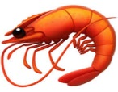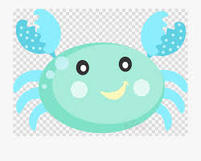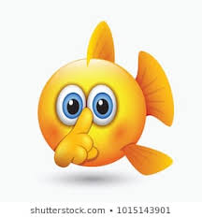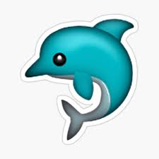 | Understanding the world: From 1.00pm, watch All the Way to the Ocean, an animated film to show how rubbish gets into the oceans through drains and what happens to the sea creatures who eat them. Afterwards, talk to a grown up about what you can do to help stop pollution in the sea. Then I would like you to count how many times in one day you put rubbish into the bin. You could keep a tally, like you did last week.
9.30am, Rockpool Ramble: Visit the National Marine Aquarium at Plymouth for a rockpool ramble. Choose your favourite creature found on the ramble, draw it and sound out to write a sentence about it. Remember to use your sound mats and to start your sentence with a capital letter, use finger spaces between your words and use a full stop at the end of your sentence. Then check that your sentence makes sense  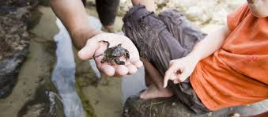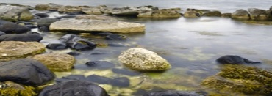 | Art activities: At 1.00pm the Ocean Creation Zone opens – with a grown up, choose activities which are appropriate to your age. You may choose to make your own hammerhead shark from a toilet roll, a cuttlefish from paper, become part of the Sea Monkey Crew, design a surfboard, make an ocean hat or make a rain gauge. There are so many exciting activities to choose from that you could do one every day this week!  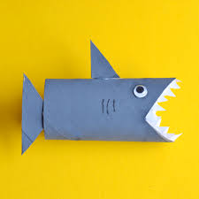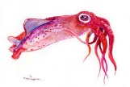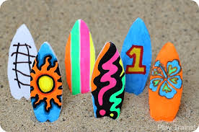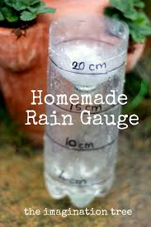
From 1.00pm, watch Sarah Roberts reading her book, Somebody Swallowed Stanley. If you miss it, you can find the story here: https://www.youtube.com/watch?v=KpXbNN38FUE  Then I would like you to talk to a grown up about Stanley. Is he really food for sea creatures? What is he? Where did he come from? Then use the attached template to make a poster to tell people why they must recycle their plastic rubbish correctly and not let it go into the sea. Perhaps you could display your poster where it can remind people to recycle their rubbish.  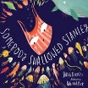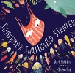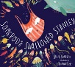 | Under the sea number ordering: Ask a grown up to print the under the sea numbers, cut them out and use the grid to place them in the correct order from 1-20. Keep counting to check you have got the numbers in the right  order.  1 2 3 4 5 6 7 8 9 10 11 12 13 14 15 16 17 18 19 20
 | I would really love to see which activities you have chosen, please remember to send your World Ocean Day pictures to Mrs Wakeham: jwakeham@pelyntprimary.co.uk

