My Kite Design
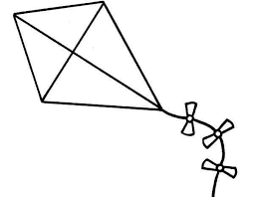
My recycled materials are:
Include the colours and other design features of your kite.

