World Ocean Day – Monday 8th June 2020 - feel free to complete as few or as many of these activities as you like, there is no pressure!
Dress in blue, which is the dress code for celebrating World Ocean Day on Monday 8th June 2020 (or, if you wish, you could dress in any other colours or costumes linked to the ocean!)  Then log onto World Ocean Day and choose your activities for the day: https://worldoceanday.school/  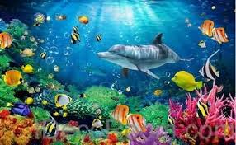  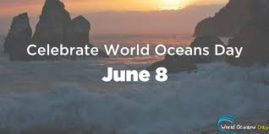 | 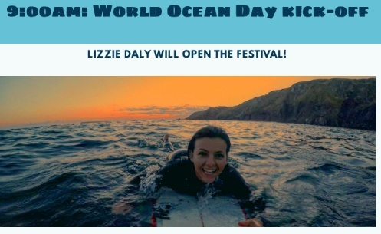  At 9am, join Lizzie Daly and Richie Norton for some breathing and movement exercise!
9.30am, Rockpool Ramble: Visit the National Marine Aquarium at Plymouth for a rockpool ramble. Choose your favourite creature found on the ramble, draw it and create a fact file about it. You could use the internet to find out further information.  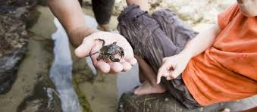  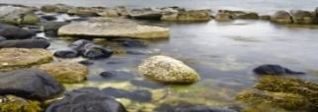 | 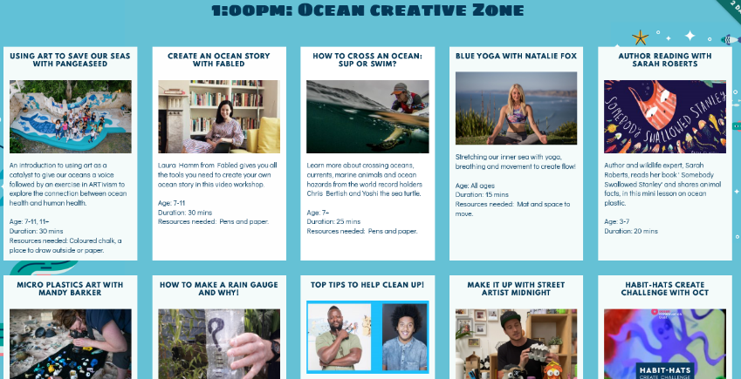  From 1pm, the ocean creative zone opens where you will be able to choose age appropriate activities (check with your adult at home) to complete. There are lots of exciting and interesting ideas on there to choose from. However, you may have your own creative activity ideas which you would like to try which is great and I can’t wait to see what you get up to on Ocean Day!
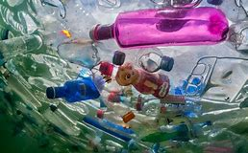
See uploaded ‘plastic or not plastic’ resource sheet. Create your own key to show which items you think contain plastic; I think you might be quite surprised! I have uploaded the answers too so you can check your guesses!
Please send any photos to rhorn@pelyntprimary.co.uk

