“Oggy, Oggy, Oggy” topic grid
Create a photo collage (on the computer or printed) using photos that you have taken in Cornwall. | 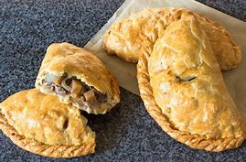  Research the history of the Cornish pasty. Design your own pasty and draw a cross-sectional diagram with a short explanation. | Write a diary/recount about a place in Cornwall that you have visited.  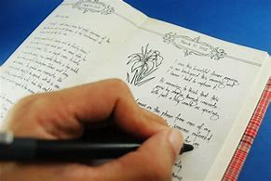 | 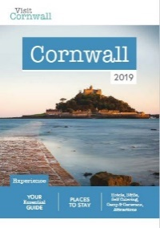  Create a tourist information brochure. Think about the leaflets you can pick up in different places, what do they look like? What sort of pictures do they have?
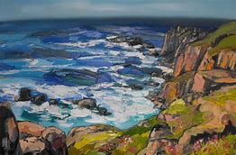  Draw/ paint a picture of a Cornish landscape. | 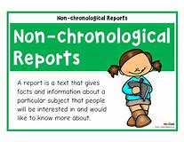  Research Cornwall and write a non-chronological report about it or create a fact file. | 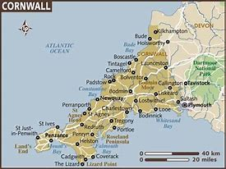  Draw a map of Cornwall and plot the cities and towns. See if you can accurately label where you live. | 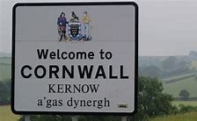  Research the Cornish language and see if you can learn some basic phrases. Maybe you could teach them to a member of your family.
Design your own Cornish tartan.  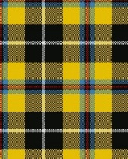  Each colour has a special meaning, see if you can find out and make sure you jot down your findings. | Make a model of a well-known landmark or monument e.g. St Michael’s Mount, The Hurlers, Tintagel Castle.  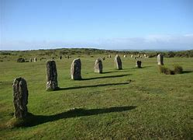  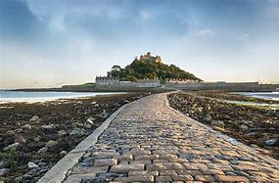 | 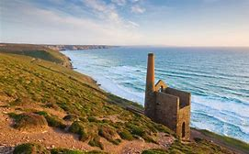  Research the history of tin mining. Present your findings in a way of your choice e.g. poster, fact file, PowerPoint etc.  Learn about beach safety, follow this link for activities:  https://rnli.org/youth-education/education-resources/upper-primary | 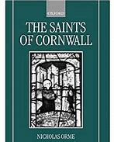  There a patron saints of Cornwall, can you find out who they are? What are they the patron saint of? Think about how you could present the information that you find out. You could make models of them, draw them, paint them, write a paragraph about them etc.
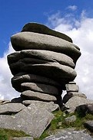  Make your own monoliths/ stone creations e.g. The Hurlers, Cheesewring, Duloe stone circle. | 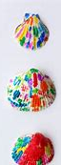  If you visit the beach, collect some materials to create a collage.  You could also collect some shells/pebbles and paint them. | 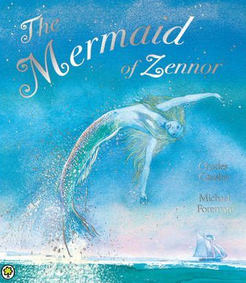  Find out about some of the Cornish myths and legends. Could you turn one of them into a comic strip to explain the story? | 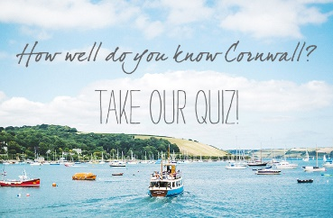  Create a quiz for your family about Cornwall. Use your research to write down the questions and answers.
If you could re-design the Cornish flag, what would it look like? Draw and explain your design and what the colours represent.  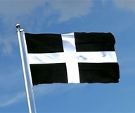 | 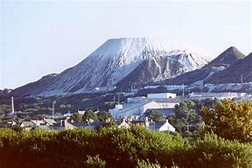  China Clay was discovered in 1745 by William Cookworthy. If you have some clay, make a Cornish monumnet out of it. If not, maybe you could ask an adult to help you make some salt dough instead. | 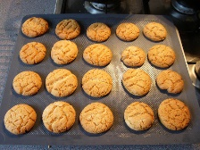  There are lots of traditional foods of Cornwall such as the pasty, fairings, saffron cake and stargazy pie. Research a traditional recipe and see if you can follow it to make some delicious Cornish cuisine. | 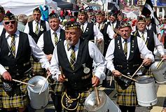  Research the Cornish culture and traditions. Present your findings in an eye-catching way! Do you have any traditions in your family?
See if you can learn some Cornish dances. Have a look at this website to begin with:  cornishdance.com/  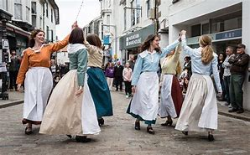  There are lots of videos available on Youtube as well. | The Lost Gardens of Heligan is a beautiful place to visit. Some of you may have been lucky enough to visit before. Research the history and present it on a timeline. This website might be a good place to start:  https://www.heligan.com/the-story/timeline  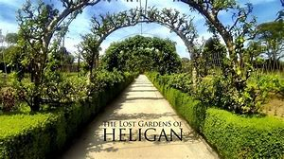 | 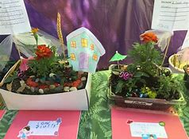  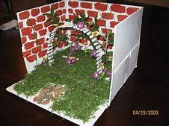  Collect materials from outside and see if you can make your own mini garden, this could be based on some of the gardens at Heligan. You could use a shoebox and lots of natural resources and materials to create your masterpiece. | 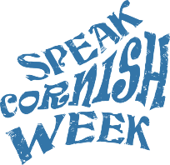  Doing it dreckly…. Everywhere has its own traditions and slang but there are some specific phrases which can be heard often in Cornwall such as ‘proper job’, ‘ansum’ etc. See if you can find out some of these phrases and what they mean!

