W/C 8th June 2020
Here are some ideas linked to English/writing that you can choose from to complete this week:
- Listen to the story of how Arthur became King.
https://www.bbc.co.uk/bitesize/clips/zvmw2hv
Jot down the key events of the story on the uploaded grid/ in your books.
Think about Why were they looking for a new king?
Who was the magician?
What challenge did he set?
Who tried the challenge?
Why did Arthur pull the sword from the stone?
What happened to Arthur afterwards?
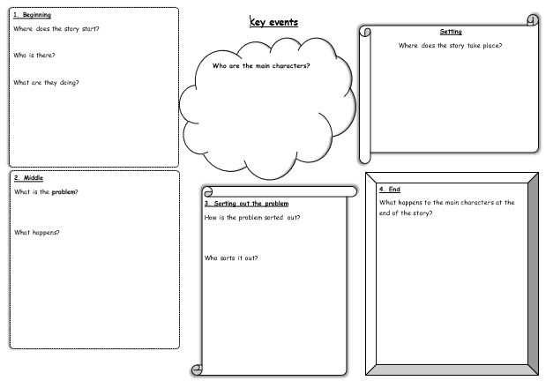(larger copy in uploads)
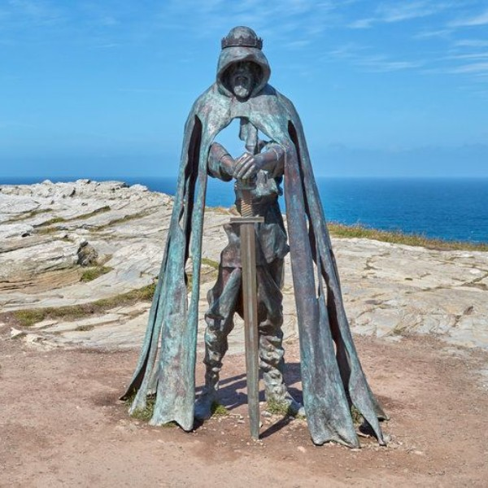
- Who is this?
How did he get there?
Why is his hood up?
Why is he standing there on the cliff?
Where is the cliff?
Why is he not solid, why can you see through him?
Write a drabble (a 100 word story) about this statue using your new knowledge about King Arthur.
Success Criteria: *Get straight to what you’re trying to say *Use as few words as possible *No wasted words, you have to be precise

- Prepositions – watch the clip on bitesize and then have a go at the prepositions mini test in the uploads.
https://www.bbc.co.uk/bitesize/topics/zwwp8mn/articles/zw38srd
- Read, retrieve and record information from the internet.
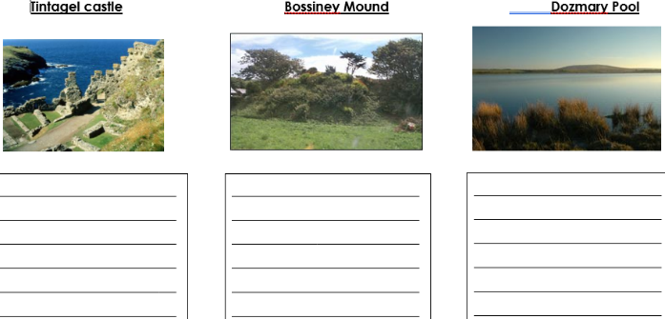
Cornwall is an area of great importance in the legend of King Arthur. Research these places and find out why they are so important: Tintagel Castle, Bossiney Mound and Dozmary Pool. See uploaded template (Cornish places) and use website below as a starting point, if you wish: http://www.arthur-online.co.uk/index.php/the-trail

