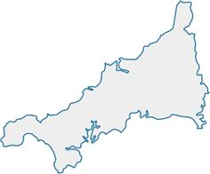

Wednesday 10th June 2020

These are the ‘things’ I associate with Cornwall