Hello Class 2,
I hope you have had a lovely weekend.
Monday 8th June is World Oceans Day. World Oceans Day is all about looking after our oceans and seas and saving our ‘blue planet’! On their website there are live ocean films, science lessons, music performances, yoga, breath-work, story telling and lots more! The link is https://worldoceanday.school/. Here you will find a whole timetable of different events for the day. It looks like it’s going to be great fun and very informative! I have put the time table below:

9.00am: World Oceans Day kick-off
9:30am: Rockpool Ramble at the National Marine Aquarium in Plymouth!
10:00am: Learn how to breathe like a dolphin
10:30am: Ocean Learning Zone – a selection of different lessons to choose from
1:00pm: Ocean creative Zone – a selection of different activities to choose from
4:00pm: Songs for the Ocean
6:00pm: Films for the Ocean

I have also included a grid below with some different activities related to our oceans and seas that you can choose from for the rest of the week.
My email address is lforbes@pelyntprimary.co.uk if you want to ask any questions or to send me some photos.
Mrs Forbes

Plastic Pollution  Read about plastic pollution below and why it is so important we use less plastic and recycle it to save our oceans and seas.  There are also10 creative ideas for reusing a plastic bottle. | What am I?  Under the Sea description game  Use the PowerPoint presentation on the blog. Can you use the clues to guess what sea creatures are being described?  Can you create your own clues and ask your families to guess what you are describing? | Under the sea craft  See ideas below for lots of creative ideas. | Diver picture  Look at the picture below of a diver under the sea.  Imagine you are the diver. Can you write about the kind of things you would see and do?
Salt dough shell fossil imprints  See below for recipe and ideas. | Acrostic poem  Can you write an acrostic poem using the letters of ‘WORLD OCEANS DAY’.  Remember an acrostic poem is where the first letter of each line spells a word.  Use the sheet in the blog to write your poem. | World Ocean Day Word search and Colouring sheet  See resources in the blog. | Ocean and sea songs  Follow the link below to learn some ocean and sea themed songs.  https://www.bbc.co.uk/teach/school-radio/music-ks1-sun-sea-song-index/zr4x2sg

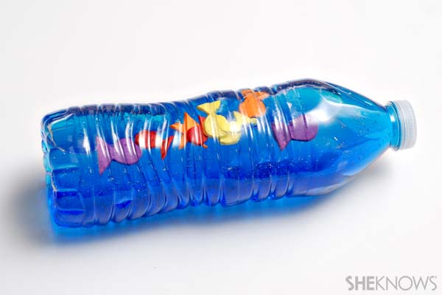
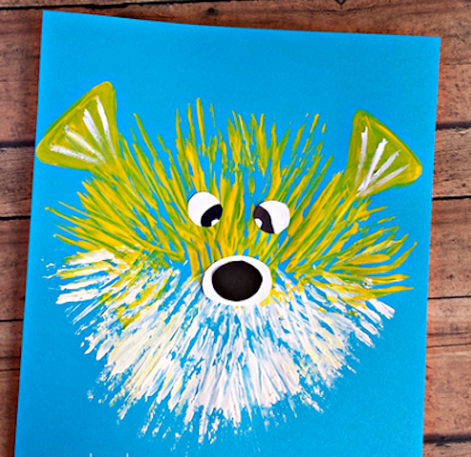
Under the Sea craft

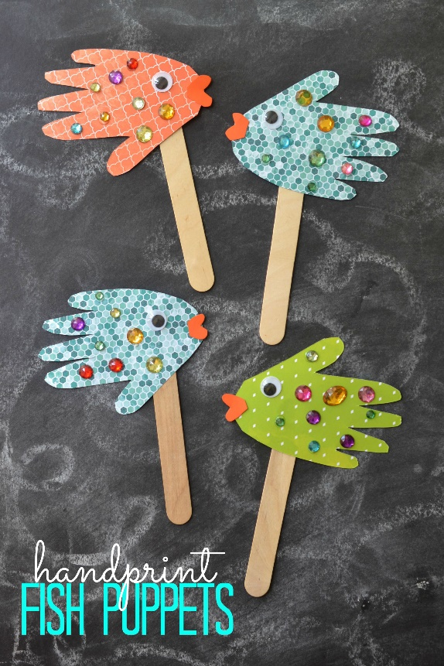

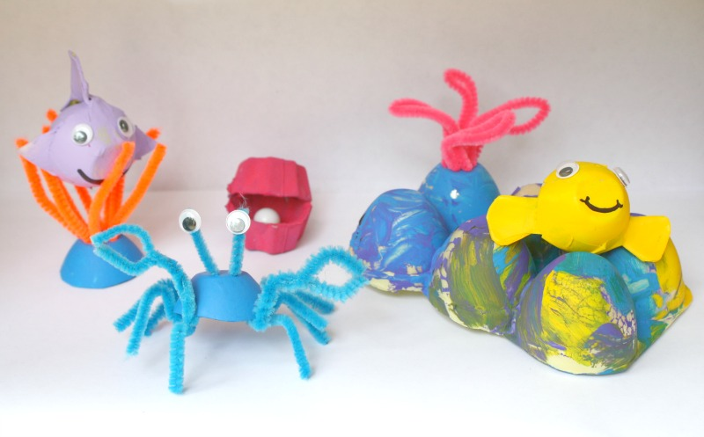

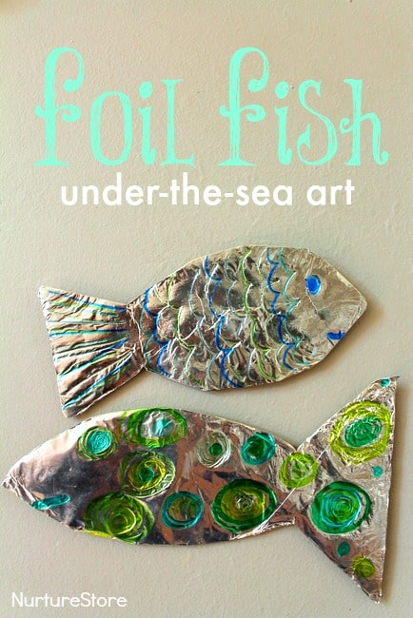

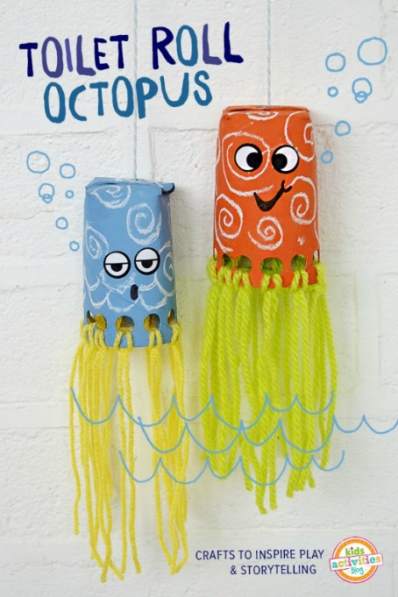
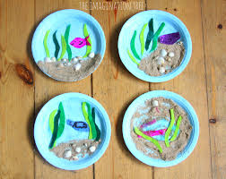

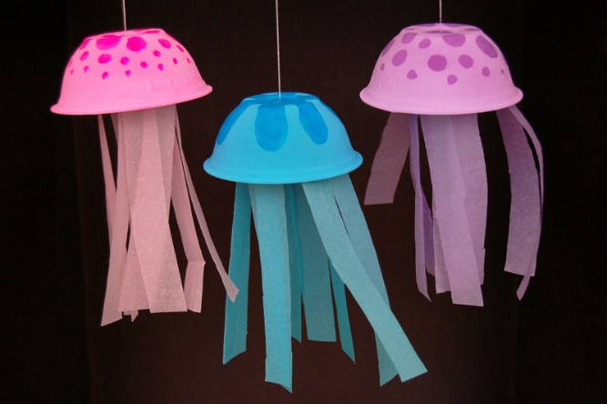

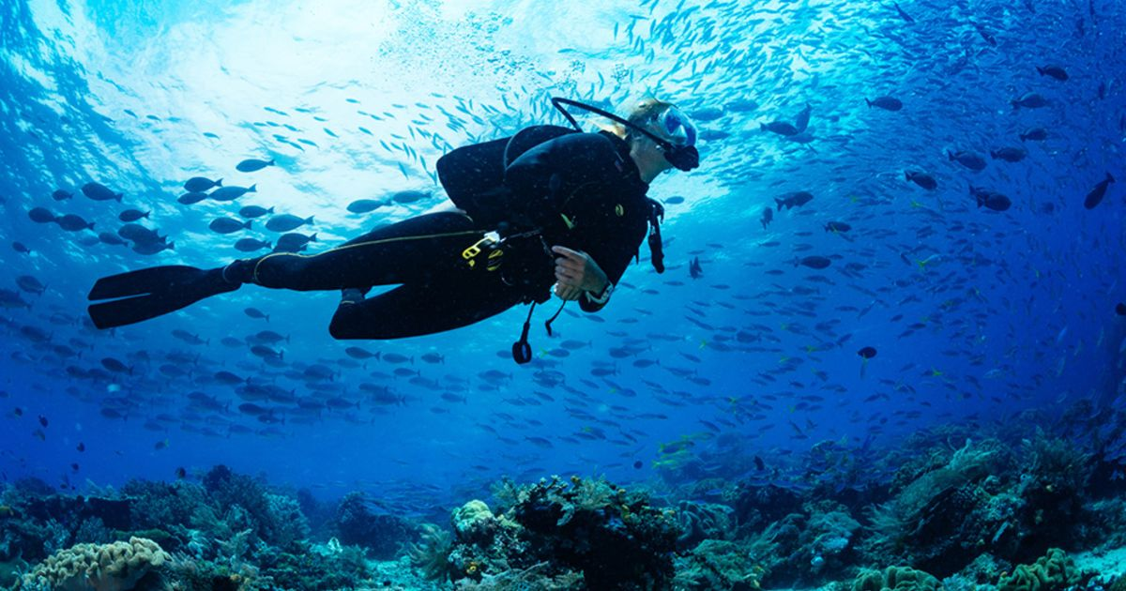

Salt Dough Recipe
- 1 cupful of plain flour (about 250g)
- half a cupful of table salt (about 125g)
- half a cupful of water (about 125ml)
Method
1. Preheat the oven to its lowest setting and line a baking sheet with baking parchment.
2. Mix the flour and salt in a large bowl. Add the water and stir until it comes together into a ball.
3. Transfer the dough to a floured work surface and shape into your chosen model.
4. You can place your finished items on a lined baking sheet and bake for 3 hrs or until solid. Or if you have left the shells in the dough you can leave to air dry.

