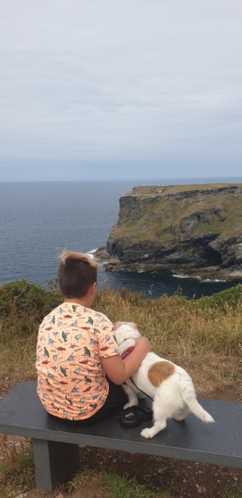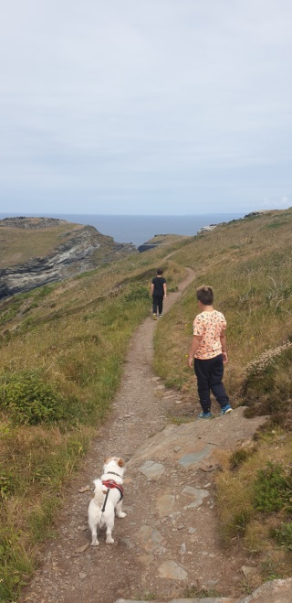**Our King Arthur quest…..**

We set off to find out about the legend of King Arthur …….

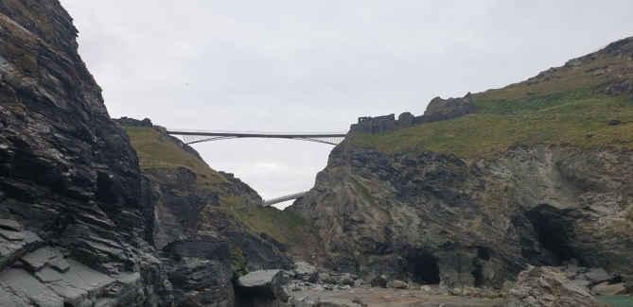

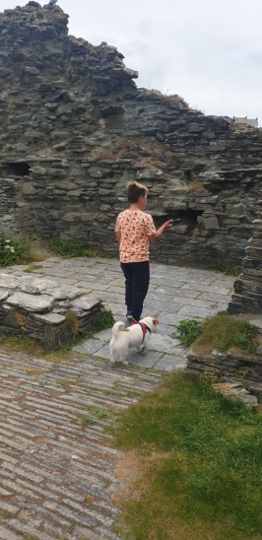

We found Tintagel Castle- which may have been King Arthur’s Camelot Castle- built on top of the cliffs on an island. Today it is just a pile of rubble but we had fun exploring it anyway. There is a big sculpture of King Arthur on the island.

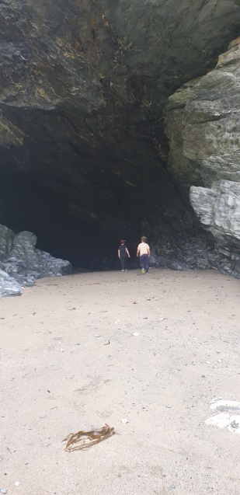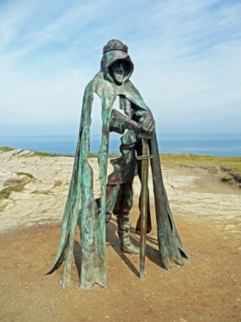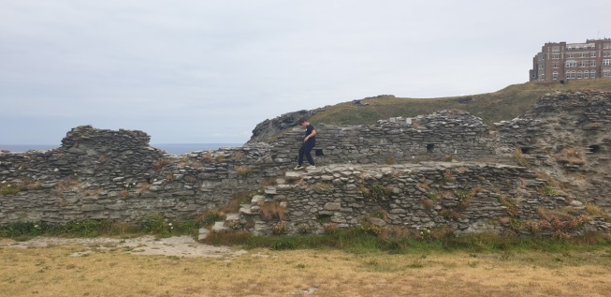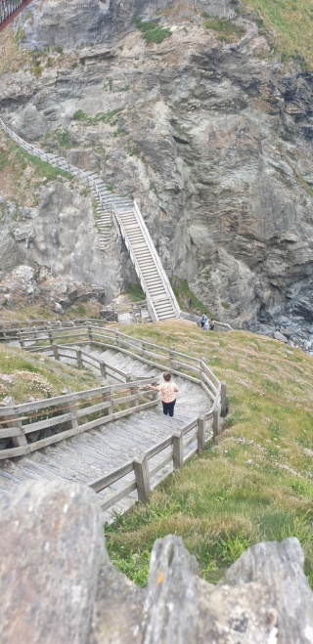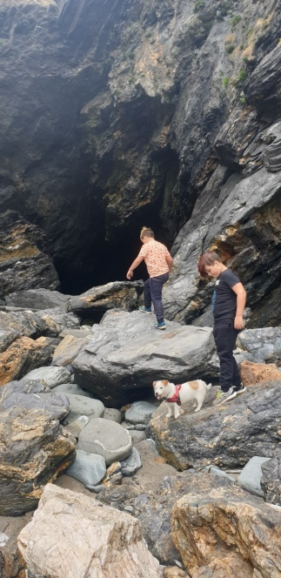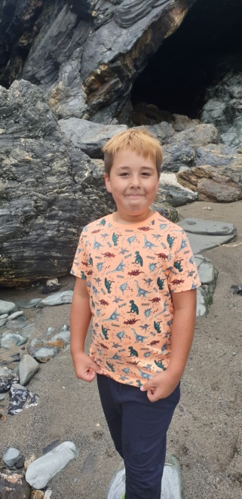

We climbed the many many steps down to the cove and explored the caves- one of them was called Merlins’ cave , and went right underneath the island where the castle was built. It was huge!

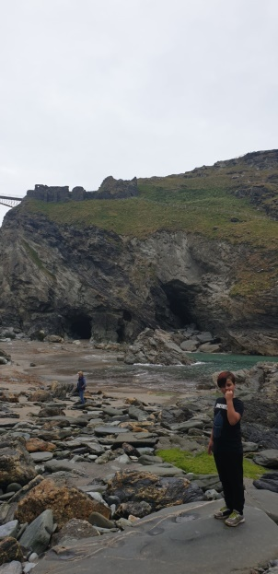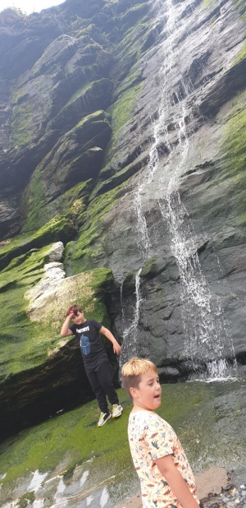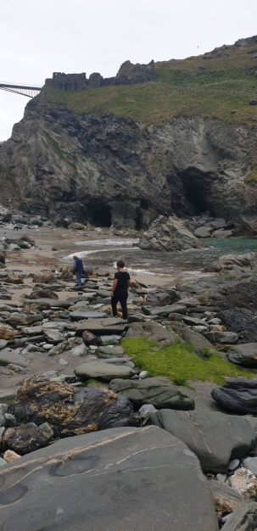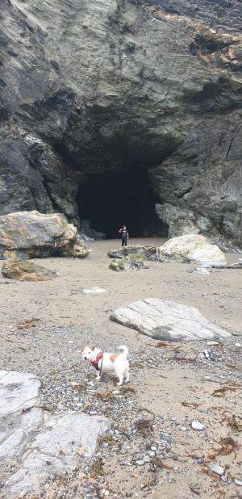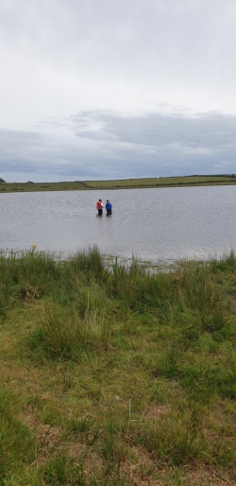

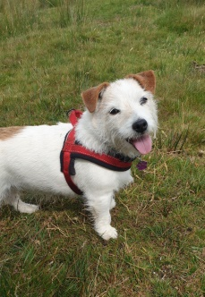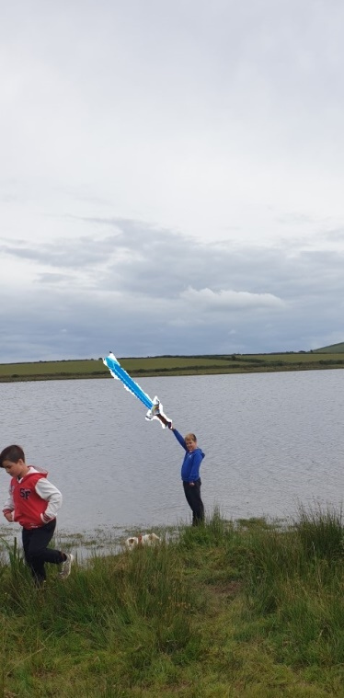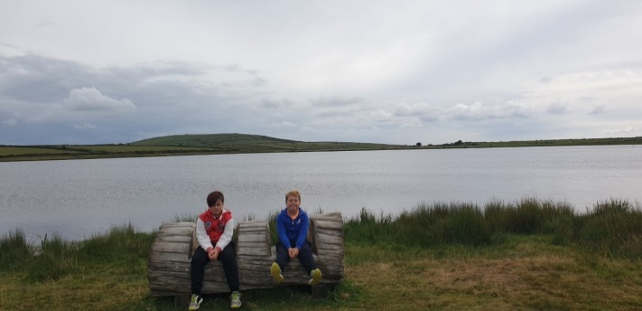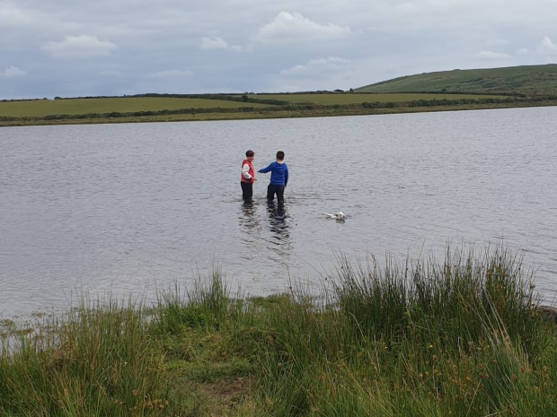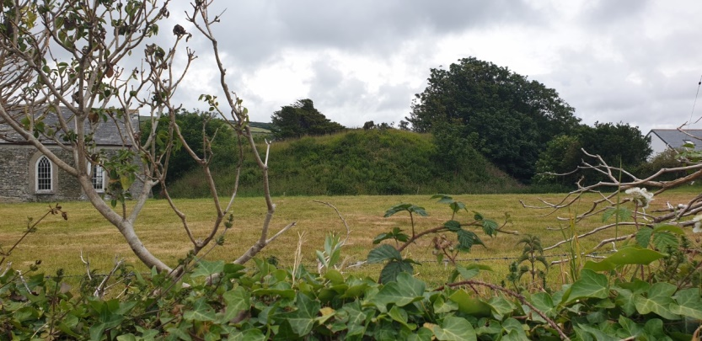

…. Or did we….?!!!!

Our last adventure was finding Dozmary Pool- in the middle of Bodmin Moor. This is where Sir Bedivere threw Excalibur- the magic sword of King Arthur. Apparently the Lady of the Lake caught it- we had a good look but didn’t find it…..

We went in search of Bossiney Mound, where legend states King Arthur’s Round Table was buried. It magically appears every midsummers’ eve, but all we found was this…..