For your home learning this week, please watch the story of Stanley’s Stick being read: https://www.dailymotion.com/video/x6felud
Creative ideas:  - Stick painting: find a stick and a feather (or other natural materials), attach the feather to the stick and use it as a paintbrush. Or you may like to have fun testing different sized sticks in different colours to make a pattern.  - Make a game: find a selection of sticks and make your own ‘pick a stick’ game. Hold a handful of sticks on their ends and then let them go – can you remove them, one at a time, without moving any of the others? You need to focus hard for this!  - Bark rubbings: use thin paper and crayons to make bark rubbings of different trees/sticks – do they all have the same pattern?  - Music: find two strong sticks and see if you can keep the same rhythm as the lady in this clip: https://www.youtube.com/watch?v=ojOJUscLAHM  - Make a picture frame: find four sticks the same length and then ask a grown up to help you join them together with string to make a square or rectangle. Then decorate with natural things like leaves, feathers etc. Then choose something special to put in your frame and take a picture.  - Make a bubble wand: find a Y shaped stick, attach a piece of wool across the top and see if it works as a bubble wand. Experiment with sticks of different sizes and shapes. Which makes the best bubble wand?  - Make a stick star: find 6 sticks of the same length – can you make 2 triangles and join them together with twine or tape to make a star which you can hang up?  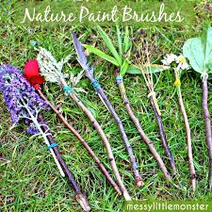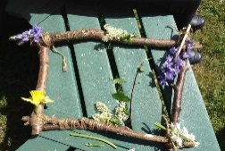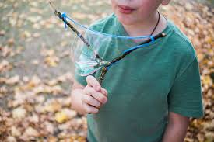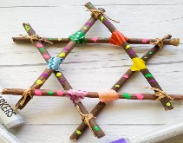 | Communication & Language/Literacy ideas:  - Use your imagination: find a stick like Stanley does and then give it a name and look after it for a few days. Tell other people what you are pretending your stick is.  - Nature walk: go on a nature walk and use your senses to talk in complete sentences to describe to a grown up what you can see, hear, smell, touch and taste on your walk.  - Describe a tree: draw or collage a picture of a tree, then write exciting adjectives around it to describe how it looks, how it feels, the sounds it makes and also describe how it makes you feel. How many words can you think of?  - Make a stick world: use sticks, leaves, stones and any other natural materials to make a small world for your favourite toy creatures/characters. Tell the story of what happens in their world to a grown up, starting with, ‘Once upon a time there lived…’
Maths ideas:
- Make shapes: find a selection of sticks – how many different 2D shapes can you make with them. Name and describe each shape.
- Stick numbers: find several sticks and practice writing numbers with them – which number can you get up to? Take pictures.
- Number of the week investigation: our number of the week is 19 – find 19 sticks and see how many ways you can make 19 – write them as number sentences (eg: 15+4=19). Can you make a stick picture using exactly19 sticks?
- Comparing length Challenge: collect several sticks of different lengths – can you place them in length order? Which is the longest/ Shortest?
- Measuring challenge: find a small stick and use it as a measuring stick – how many sticks long/high are the following objects? A table, a book, a chair, a kitchen cupboard and a bag. What else could you measure? Which is the longest/shortest item? You could practice your number writing by noting down each measurement.
*REMEMBER TO SEND PICTURES OF YOUR HOME LEARNING TO MRS WAKEHAM – I love to see what you have been getting up to: jwakeham@pelyntprimary.co.uk

