Neil Armstrong | Read and watch the videos here and then take the quiz to test your understanding:  https://www.bbc.co.uk/bitesize/  topics/zjwvb82/articles/zhx4k2p | 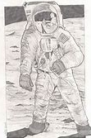  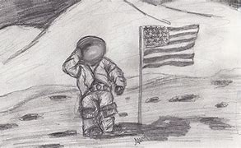  Find an image of Neil Armstrong on the moon and see if you can sketch it. Take care and use light short pencil strokes to begin with. Here are a couple of examples: | 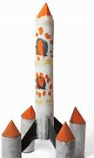  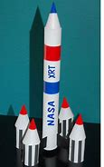  Use materials from your recycling at home (please ask an adult first) to create your own rocket. | Write an acrostic poem using the words ‘Famous People’ (see uploaded template and example)  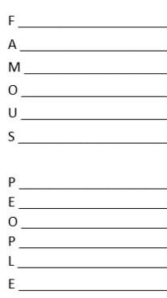
The Queen | The Queen has owned many Corgis. See if you can make some origami Corgis. Follow this tutorial on YouTube:  https://www.youtube.com/watch?time_continue=  369&v=4zmEwEscge8&feature=emb_logo | Design and make a crown – think about what colour it would be, what does it represent? | Complete ‘If I were a King or a Queen for the day I would…’ activity (see uploads) | Research the history of the royal family and create your own royal family tree. Check out this website:  https://www.bbc.co.uk/news/uk-23272491  You can present your tree in a way of your choice.
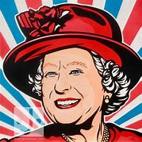
Create an abstract portrait of the Queen or a Pop art painting.

Sir David Attenborough | Attend a lesson about oceans from Sir David Attenborough on Tuesday 30th June on BBC Bitesize  https://www.bbc.co.uk/bitesize/dailylessons  Take some notes during the lesson and complete any related activities that are set on the website (it will tell you at the top on the day of the lesson if there are any) If there are not any activities set, create a poster/fact file to show what you have learnt. | 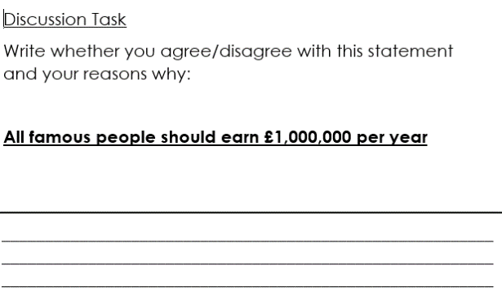  Complete the discussion activity. You could discuss it with an adult and/or write your response down (see uploads) | 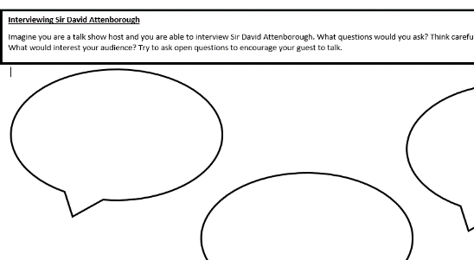  You are going to pretend that you are going to be interviewing Sir David Attenborough! Think of the questions you would love an answer to… (see uploads) | 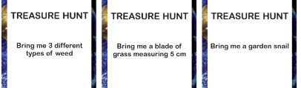  You are going to go on a Scavenger/Treasure hunt (see uploads)
Florence Nightingale | 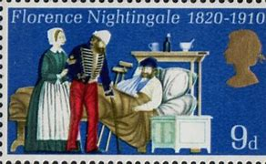  Design a collectable stamp to recognise the NHS or a famous medic | Complete the Florence Nightingale wordsearch (see uploads) | Compare a Victorian and modern day hospital – what do you notice in the pictures? (see uploads – please choose a reasonable challenge level, I think everybody should have a go at ** or ***)  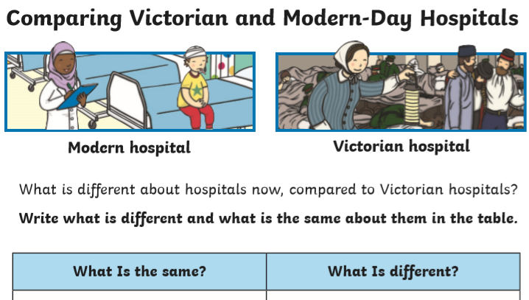 | Make a lantern out of materials of your choice. See if you can make it look like the one Florence Nightingale used to carry around.  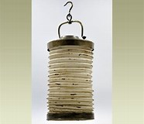
 | Complete the reading comprehension to develop your knowledge which is in the uploads.
Isambard Kingdom Brunel | Build one of Brunel’s famous creations using materials of your choice. You could use straws and masking tape, recyclable materials, playdough, sticks (collected from a walk) etc… I am sure you will have some great ideas of your own.  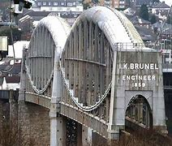 | Create a fact file about Isambard Kingdom Brunel. You could put your internet search skills into practise to search for relevant information. Remember to be safe when using the internet.  See uploads for templates, PowerPoint and facts.  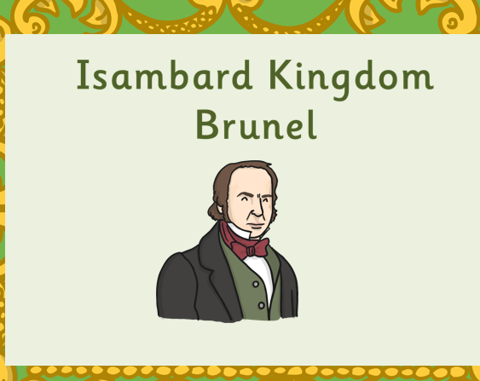 | Brunel also created some steamships. See if you can find out what they were used for. Once you find an image you like, sketch it and then add colour using any medium e.g. paint, pastel, chalk, pencil etc. You may want to experiment with creating your design on the computer.  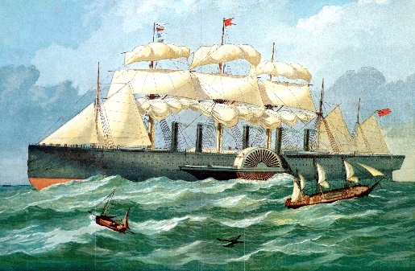 | If you were going to invent or design something… what would it be?  Draw your invention, label it and explain it.  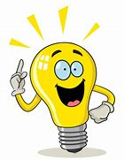  You could invent a giant vacuum that could be used in the oceans to suck up all of the litter.  You may want to invent a different style car or motorbike which could fly, float and travel on the road.  I look forward to seeing your ideas!

