Hello Class 2,
I hope you have had a lovely week enjoying the glorious sunshine.
This week is the start of ‘Children’s Art Week’. It runs for three weeks and each week will focus on a special theme. This year’s themes are:
- Week 1 (from 29 June): The Natural World
- Week 2 (from 6 July): Connecting across generations
- Week 3 (from 13 July): Literacy and creative writing
The grid below includes lots of art ideas using objects from our ‘natural world’ or based around nature. These are just some ideas; you can of course pick and choose any of them or come up with your own ideas.
As always, my email address is lforbes@pelyntprimary.co.uk if you want to ask any questions or to send me some photos.
Best wishes,
Mrs Forbes

Warm up drawing exercises  Use the sheet attached in the blog and complete the warm up exercises. Can you copy the patterns? | Take photos of the natural world  Can you go in your garden or for a walk and take some photos using a camera or camera phone (ask permission first!) to take photos of natural objects.  Can you get close to the object and use the zoom facility on the camera to ‘edit’ what you can see?  Pick your favourite photo and maybe you could try and sketch what you can see in the photo you have taken. | Flower crown or mask  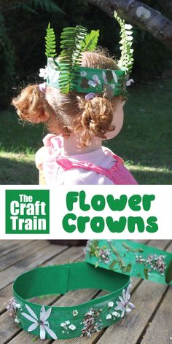  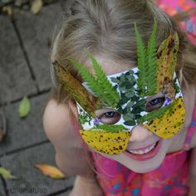 | 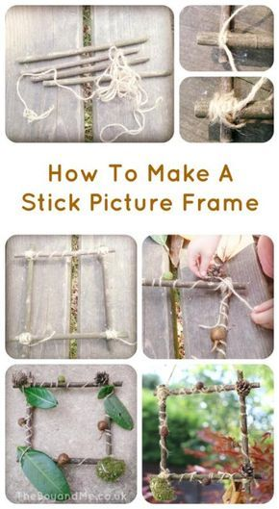  Stick picture frame
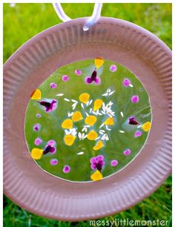  Flower petal and leaf suncatcher | 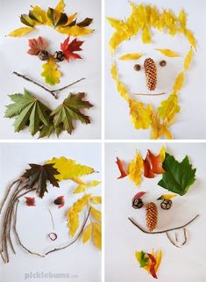  Natural portraits | 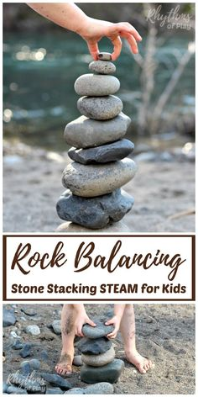  Rock balancing | 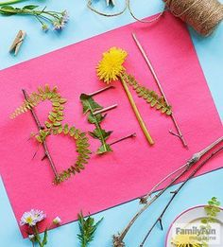  Create you name using natural objects

