Rhyme Time

There are 20 words hidden for you to find. 10 words rhyme with the other 10 words.

Write down the first 6 words you find. Then use the words to make a short, rhyming poem. Even better if it’s about the next couple of months!

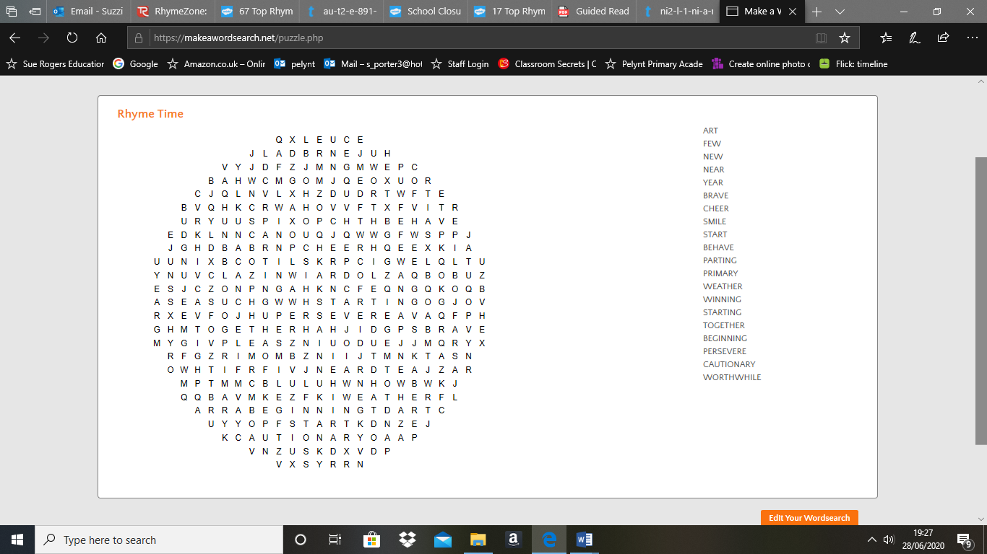

Words I have found

Rhyming poem