Hello Everyone,
We are really looking forward to seeing you back in Class 2 on Monday 7th September.
Please read the ‘Welcome Back’ sheet at home with a grown up – it will show you how things are a bit different at school since we last saw you. Some of you will already know how things have changed, but it might be helpful to be reminded.
Although so many things have changed recently, the grown ups in class 2 will still be the same, with the exception of Mrs Rickard, who will be moving to class 3.
We hope you have had a lovely holiday and look forward to finding out what you have been up to.
 | Mrs Fenton has spent some time on the beach and lots of time at home with her little boy, who is 8 years old. She has been playing football with him and also went to Wales on a very rainy family holiday. She also enjoyed visiting Longleat and seeing lots of different animals including lions.
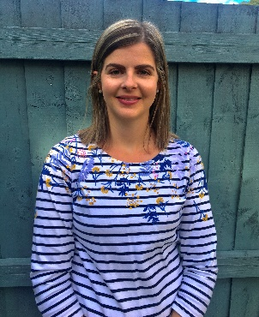 | Mrs Forbes has been enjoying the outdoors and going on walks with her family. She has enjoyed being at the beach, exploring the rock pools and splashing in the sea with her little girl. She has also spent lots of time at home, either in her garden, reading stories or cooking. She loves being a teacher in Year 2 and can’t wait to see her new class in September.
 | Mrs Harper has had a lovely holiday with her family. She has a daughter who has been helping with walking their 2 dogs on the beaches and a son who she has been learning to drive. She has been helping Mr Harper build new decking in the garden and bringing him lots of cold drinks! She has also had a new kitten in the holiday so lots of playing with him.

See you back at school for lots of fun in September

