Welcome back

We would like to show you some of the ways we will be keeping you safe when you return to school. Please take some time to read and look at the photos of what you will expect when you return on 7th September 2020. We will be there to help you.

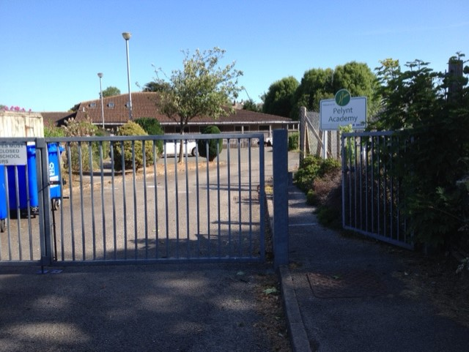

First, you will notice that you must only enter the school grounds from the main gate. This is so that we can have a one-way system.

Learning

We are trying our best to make sure that you feel safe and really enjoy the learning we have prepared for you. We will also do lots of playing and getting to know the new friends in your class.

You will then go into the classroom, stopping at each of the markings. Mrs Fenton and Mrs Harper will be there to help you.

You will only be with the children in your class while you are at school. We call each group a ‘bubble.’ You stay only with the people in your bubble when you are indoors and outdoors during the day.

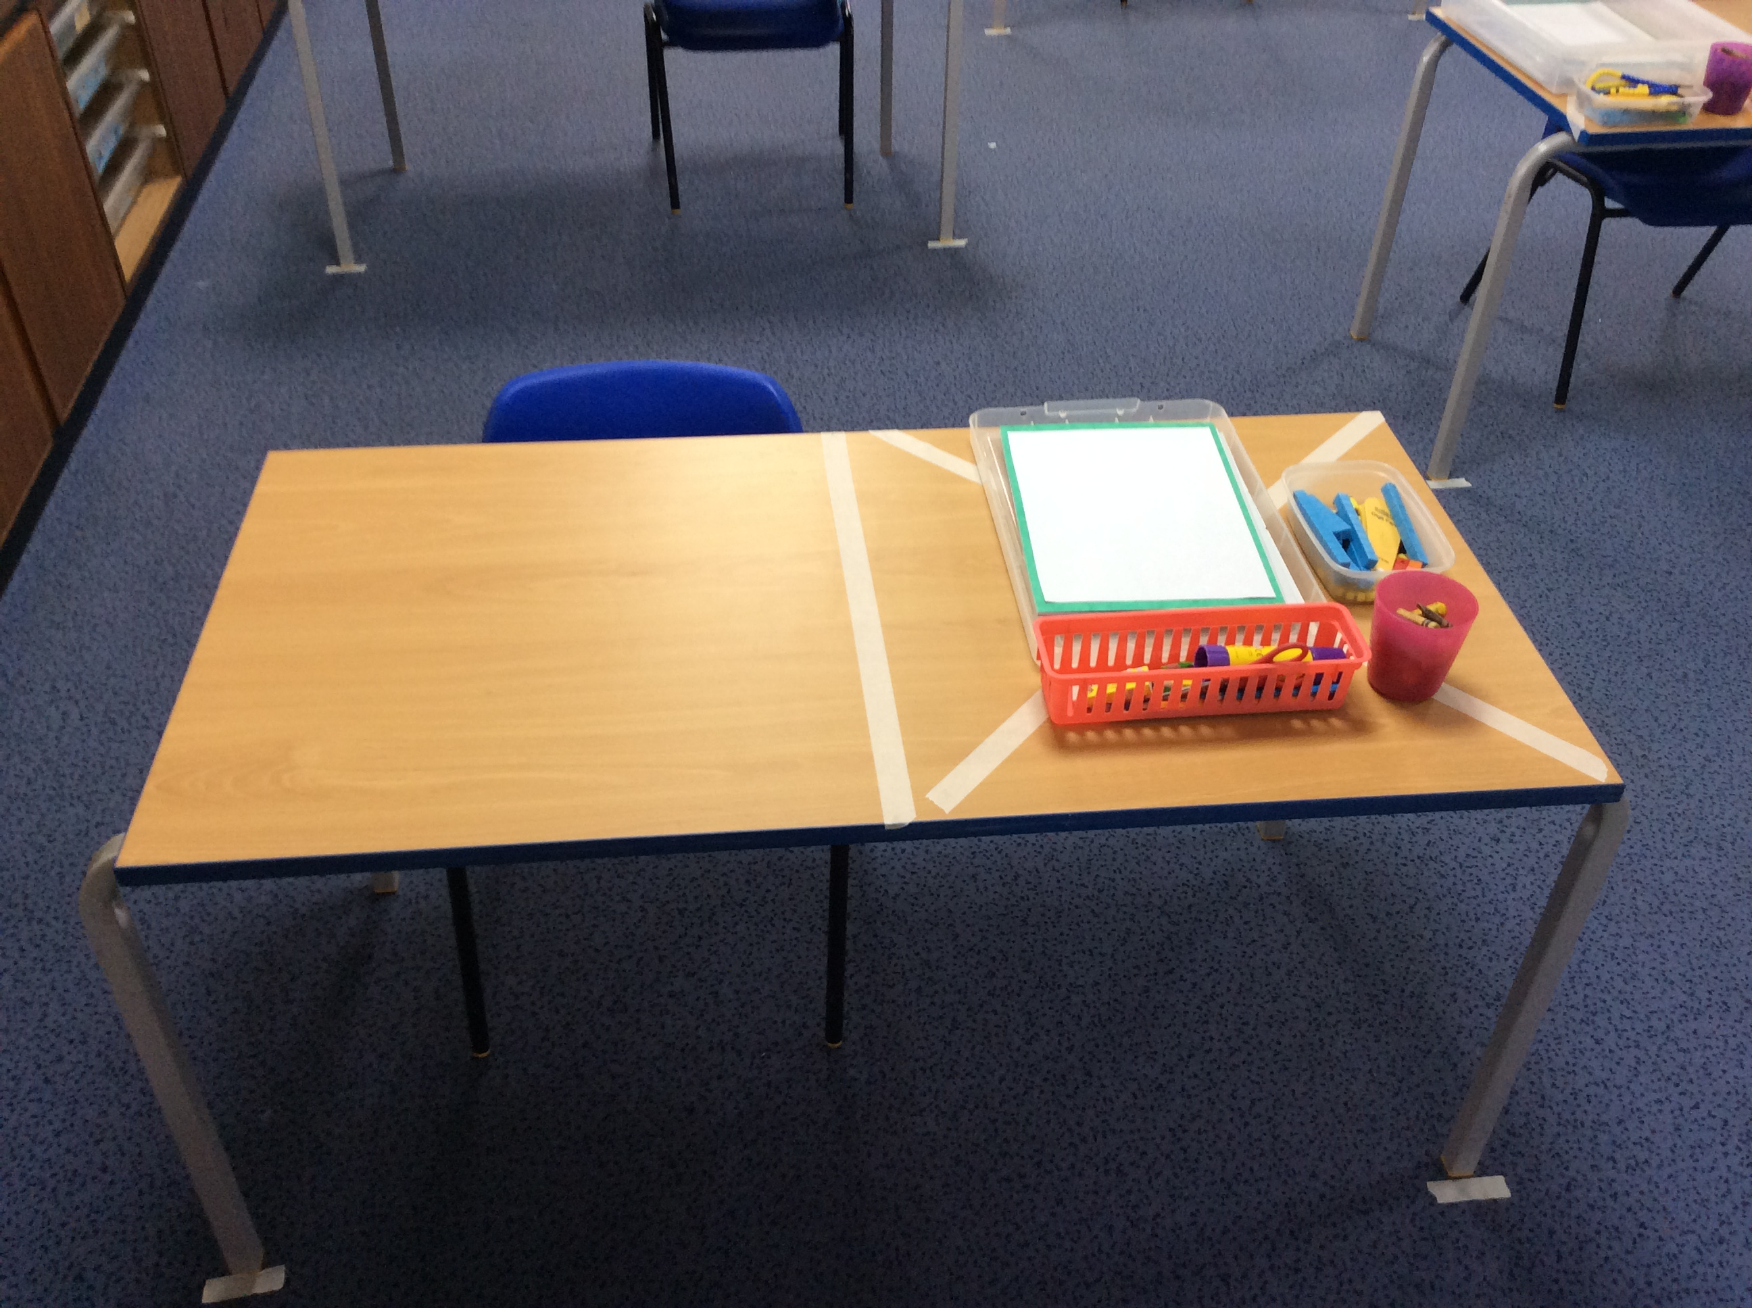

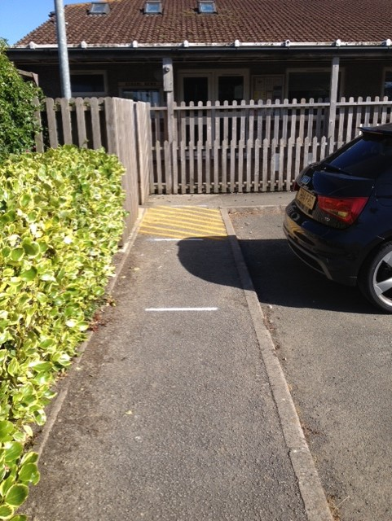



Class bubble

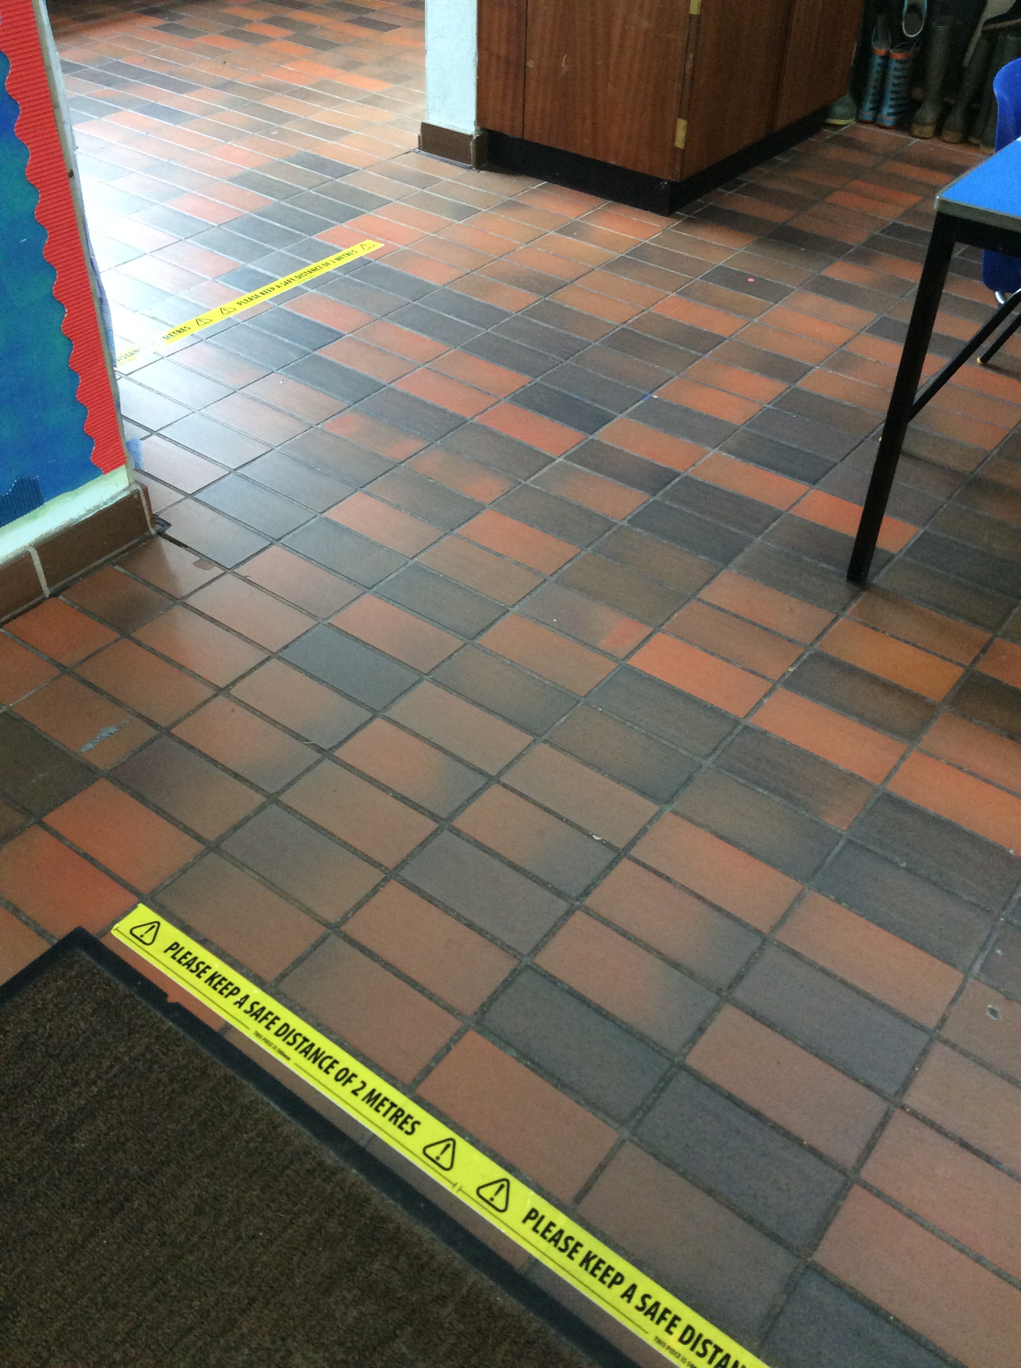

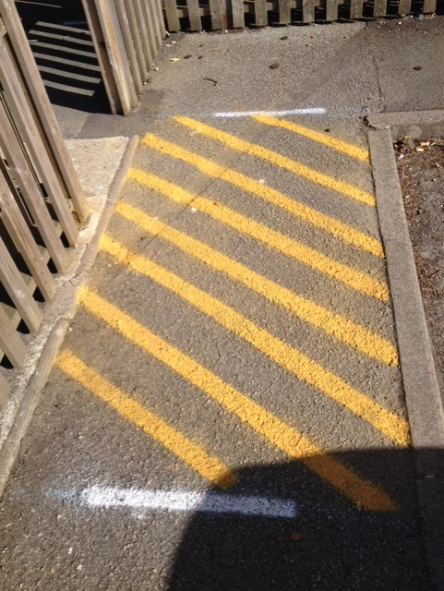

In the classroom you will notice that all the desks are

facing forwards. You will have your own space with

your own resources. For the moment we mustn’t

share resources in school.

When you get to the wooden gate an adult will be there to greet you. Please don’t step into the box until you’ve said goodbye to your parent and are ready to walk straight in. We need to keep this box clear at all times.

You must follow the markings and keep 2m apart as you walk along the path.