Page 2 Weclome back

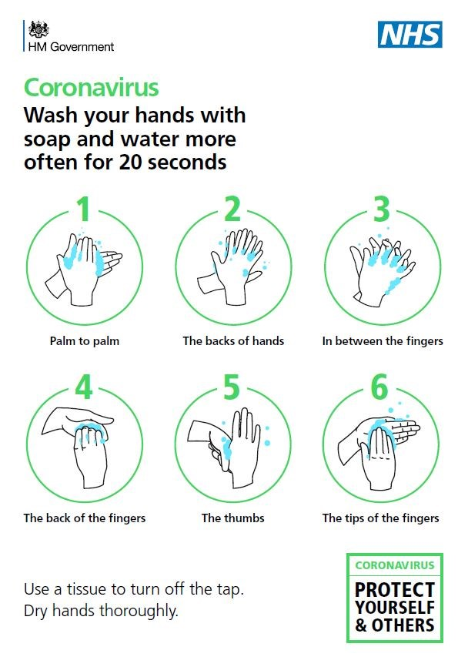

You will need to wash your hands as soon as you get to school. During the day we will remind you of the times you need to wash your hands. This is the most important way to stay safe. We will teach you a song to help you with this.

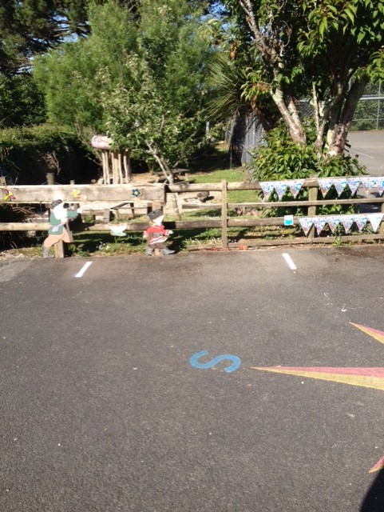

During the day your teachers will be helping you to keep the classroom clean. The desks and other surfaces that are touched regularly will be sprayed and wiped clean throughout the day.

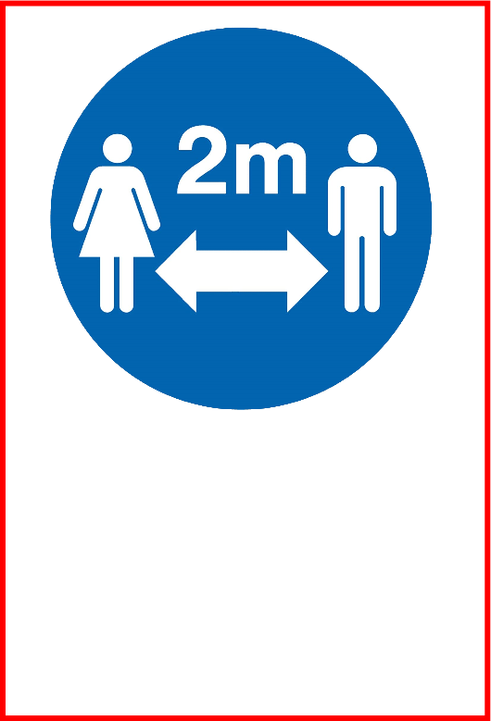

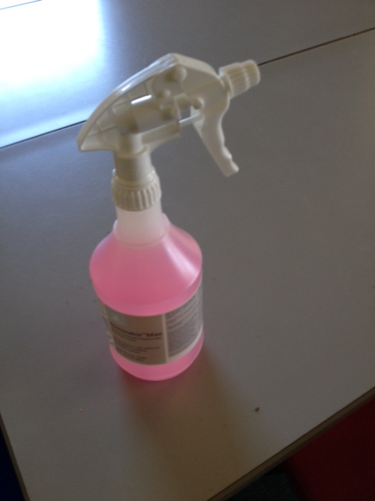

When it is time to go home, your teacher will lead you out. When your parent reaches the gate to collect you, your teacher will tell you and you can walk to meet them. You will then be able to go out through the gate to meet your parent.

We are really looking forward to seeing you.

We will try to spend as much time outdoors as possible so please make sure you are ready for the weather. It has been very warm lately so please make sure you have put sun cream on before school. Don’t forget to bring coats when it looks like it might rain.

Lunch

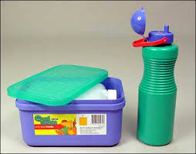

You will eat lunch in your classroom or sometimes will be able to have a picnic outside. Please only bring your lunchbox and a drink bottle each day. You will be able to refill your bottle with water during the day.

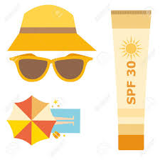

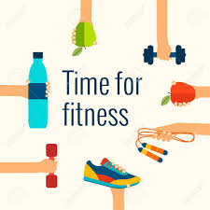

It’s important that our body and mind stay healthy. We can’t have PE lessons for a while, but we will be having daily exercise sessions for 30 mins. This is in addition to playtimes. You will not need to bring a PE kit for this.

At the moment we can’t play some of the games we were used to. We will need you to help invent some new fun games where we can have fun and stay safe.

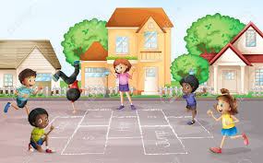

Your teacher will introduce you to the new rules and can explain them to you. It is very important that we all follow these rules to keep ourselves and each other safe. There are lots of posters around to help you remember.