**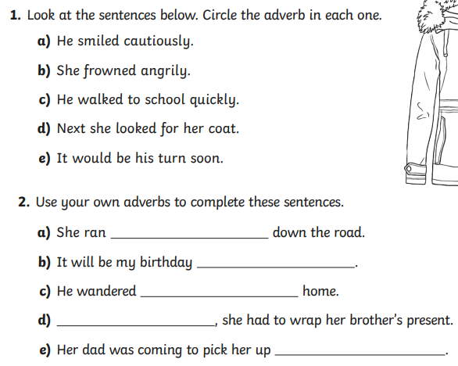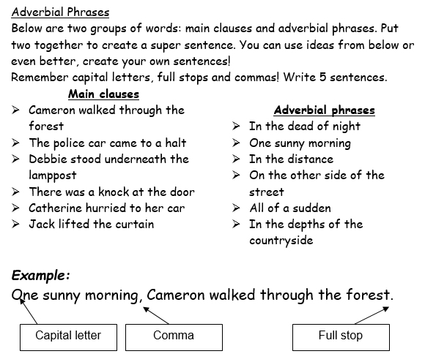\*\*Adverbs describe how the action is carried out\*\***

Copy the sentences down and add your adverbs.

Identify the adverb and write it down.