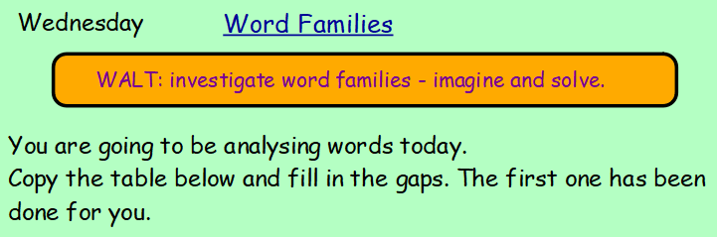

Word | Vowels  a e i o u | Consonants  Any of the other 21 letters of the alphabet (except the 5 vowels) | Syllables | Synonyms | Definition (meaning)
solve | 2 = o e | 3 = s l v | 1 | answer, resolve, work out | Find an answer to or an explanation for a problem
solved
dissolve
imagine
imagination
imaginative

