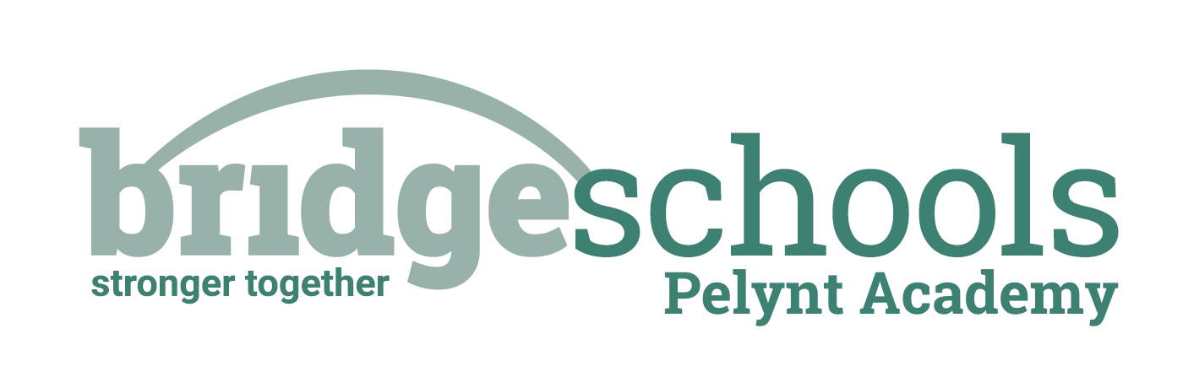
Pelynt Academy
Pelynt,
Looe,
Cornwall, PL13 2LG
Tel: 01503 220262
www.pelyntprimaryschool.co.uk
secretary@pelyntprimary.co.uk

Thursday 14th January 2021
Maths:
Today, if you are in pink group, your learning objective is to use the multiplication symbol. Please watch the video below (multiplication using the x symbol) and complete the attached questions.
https://whiterosemaths.com/homelearning/year-2/week-1-number-multiplication-and-division/
Today, if you are in orange group, your learning objective is to multiply 2 digits by 1 digit. Please watch the video below (Multiply 2-digits by 1-digit no exchange). No question sheet today but you will need a pencil and a piece of paper to answer the questions during the video.
https://whiterosemaths.com/homelearning/year-3/week-1-number-multiplication-division/
Today, if you are in green group, your learning objective is to develop effective strategies for multiplication. Please watch the video below (efficient multiplication) and complete the attached questions.
https://whiterosemaths.com/homelearning/year-4/week-1-number-multiplication-division/
**The answers are attached so that you can self-mark your work**

English:
Our grammar focus today is on prepositions. Watch this link on BBC Bitesize:
https://www.bbc.co.uk/bitesize/topics/zwwp8mn/articles/zw38srd
Then, complete the two activities on the website. 1- highlight the prepositions 2- quiz.
Next, complete the three tasks on the document in the uploads.
*Remember when writing to use capital letters, punctuation, finger spaces and say your sentence aloud before writing. Once you have written your sentences, re-read them to check they make sense.

Reading:
Read your book for 10 minutes and then complete this activity: Imagine what the setting of your book would look like and draw a picture of it. Label your picture with the words and phrases the author has used to describe it.
Be active: Choose an activity from the daily activity menu and get your heart rate up for 30 minutes.
Spelling/Phonics:
Phonics group- ‘or’ follow this link to BBC Bitesize, watch the video and then complete the online learning activity (click the arrow underneath the video)
https://www.bbc.co.uk/bitesize/topics/zvq9bdm/articles/zr6f6v4

Then, copy the words below onto a piece of paper and write the sound buttons underneath to show how many sounds are in the word. Don’t forget to use your phoneme fingers to help you!

fork torn born lord worn horn corn sort

Finally, pick four of the words and put them into your own sentence – remember capital letters, finger spaces and full stops.

Orange spelling group- Your learning objective for this week is to understand how suffixes ment and ness change the meaning of words. Remember a suffix is added to the end of a root word. See uploaded document for your task.

Green spelling group- Your learning objective for this week is to investigate word families- imagine and solve. See uploaded document for your task.

History:

We are going to be travelling back in time to 776BC when the first Olympic games were held and then look at the history of ancient Greece up to 146BC.

Your task today is to create your own timeline to show the history of ancient Greece. You can present this in any way you like e.g. use the template in the uploads as a guide, write it on post it notes, draw it on a piece of paper, make your own PowerPoint etc. The more creative the better!

You will see in the uploads a PowerPoint slide with a timeline on and also a Word document which you can listen to. Please see the instructions at the top of the document in order to have the text read to you. You could also use the internet to research the history of ancient Greece and create your own timeline of events instead of using the uploaded PowerPoint slide.

