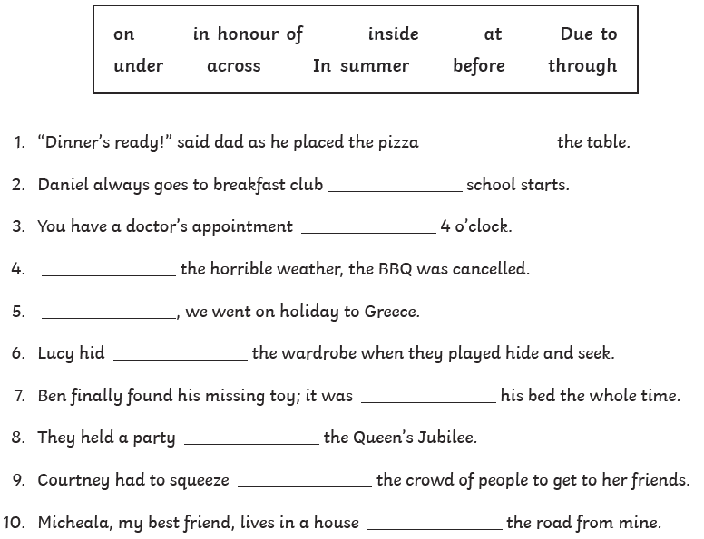
TASK 1
Read the sentences below and choose the correct preposition to fill in the gap. Make sure the sentence makes sense once you have added the preposition in.
*Save paper and ink- these sentences can be written out.
Identify the preposition:
1) The car is in the garage. 2) The chair is behind the table. 3) Peter was walking beside his friend Tom.
The prepositions in the sentences below are wrong. Write the correct preposition.
4) The cat is sitting under the carpet. ________________________
5) The car drove above the roundabout. _________________________
6) The man fell up the stairs. _______________________________
7) The CD is under the CD Player. __________________________
8) The ferry sailed below the sea. _______________________
TASK 2
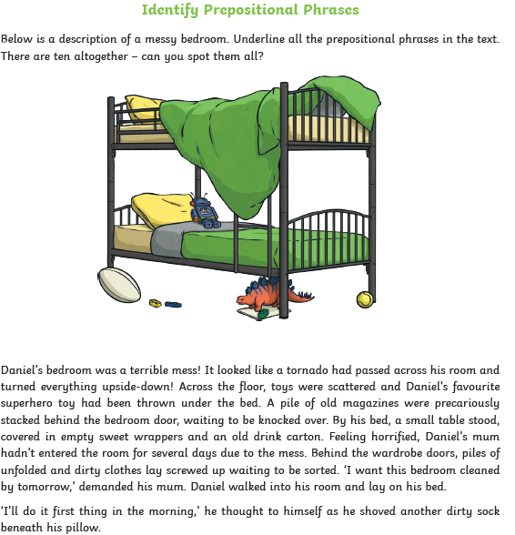
Read the text and identify the prepositional phrases. You could jot them down on a piece of paper to save printing this page.

TASK 3
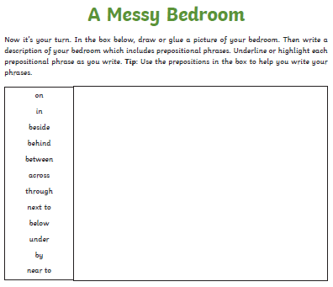
Use the template below as a guide and draw a picture of your bedroom/a room in your house. Afterwards, write a paragraph to describe the room which includes prepositional phrases.

