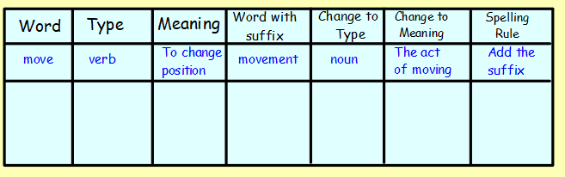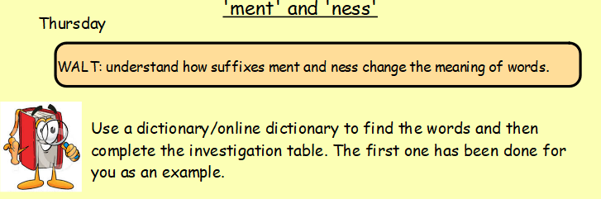

**These are the words to put in your investigation table:**

kind

silly

enjoy

happy

fair

manage