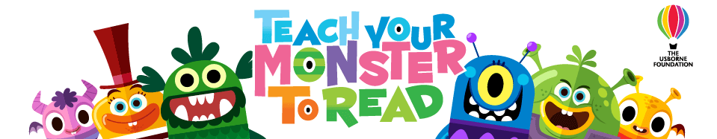
Hello,
We're here again... We know many of you are facing disruption due to school closures, so we're going to make the Teach Your Monster to Read app free once again. You can get all three Teach Your Monster to Read games completely free in one app, from Tuesday January 12 to Sunday January 17.
Once downloaded, there's nothing else to pay.
Please share this news with all teachers and parents you know, so that their kids can learn to read with our government-approved phonics and literacy games. They'll thank you for it!
Psst... If your child is likely to play the app on more than one device, then sign up for a free account at teachyourmonstertoread.com first and create a player. You'll be given player login details which you can use to play across all devices.
Download your Teach Your Monster to Read app between Tuesday January 12 and Sunday January 17 2021:
and amazon.co.uk
The BAFTA-nominated game that helps millions of children learn to read.
Teach Monster Games Ltd is a subsidiary of The Usborne Foundation, a registered charity in England and Wales. Charity number 1121957.

