Friday
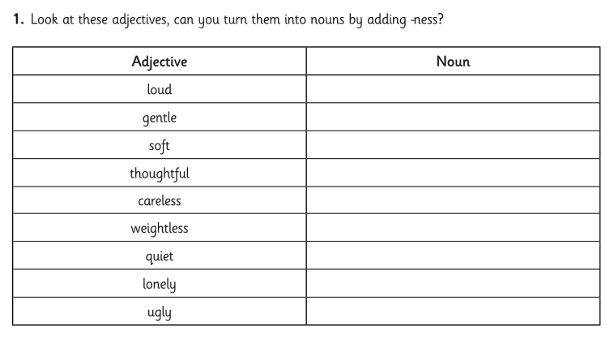
- Copy the table below and write in the nouns.
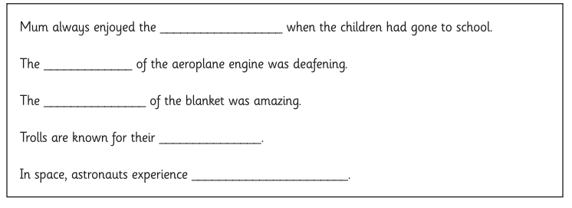
- Copy out the sentences and add in the correct noun ending in -ness from above to make them complete.

