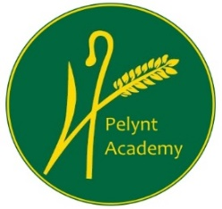
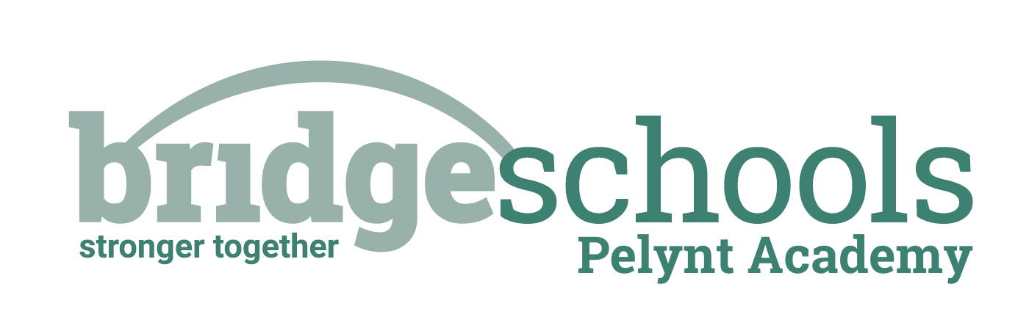
Pelynt Academy
Pelynt,
Looe,
Cornwall, PL13 2LG
Tel: 01503 220262
www.pelyntprimaryschool.co.uk
secretary@pelyntprimary.co.uk

RECEPTION
PHONICS: | https://www.youtube.com/watch?v=oR2IOpdJLfU  Lesson 9 – Review and practise blending
MATHS LESSON: | https://whiterosemaths.com/homelearning/early-years/alive-in-5-week-3/ Alive in Five! Week 3, session 1, Comparing mass – heavier and lighter than
MATHS ACTIVITY: | https://wrm-13b48.kxcdn.com/wp-content/uploads/2020/12/PDF-Alive-in-5-Week-3-Session-1.pdf Have fun comparing the weight of different objects. Which is heavier? Lighter? I have also attached another sheet to help you with this.
ALSO: | Handwriting – start with the ‘curly caterpillar family - ‘c’ today (see attached sheets, we shall practice one letter per day). Remember to choose from the daily exercise menu, practice writing your name and choose an activity from the ‘The Day the Crayons Quit’ grid.

Class 1 Daily Home Learning MONDAY 18th JANUARY 2021

YEAR 1
PHONICS: | https://www.youtube.com/watch?v=sgXywhMY_CI  Lesson 36: ir, bird
MATHS LESSON: | https://whiterosemaths.com/homelearning/year-1/spring-week-2-number-addition-and-subtraction-within-20/ Add by Counting on Activity
MATHS ACTIVITY: | Carry on with the counting on activity which was introduced in the lesson above. I have attached a set of number cards for you to print if you can. If not, maybe you could make yourself a set of 1-20 cards by writing the numbers on pieces of paper.
SPELLINGS FOR THIS WEEK: | said, says, are, were, is  Please use the attached spelling challenge to practice and ask an adult to test you at the end of the week. *Thank you to those who sent me spelling test results*
ALSO: | Handwriting – start with the ‘curly caterpillar family - ‘c’ today (see attached sheets, we shall practice one letter per day). Remember to choose from the daily exercise menu and choose an activity from the ‘The Day the Crayons Quit’ grid (choose a variety of activities across the week. Some may take longer than one day).

