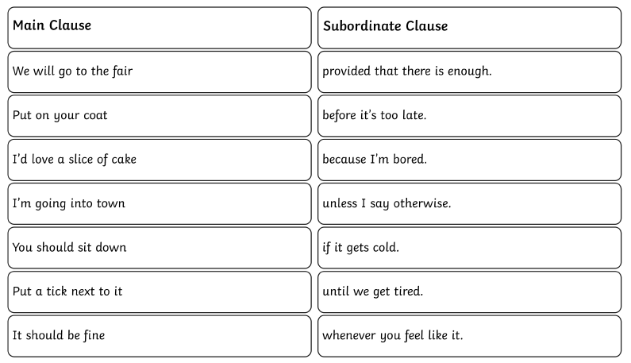
Write complete sentences by joining a main and subordinate clause. Read it afterwards to check it makes sense. You should have 7 complete sentences at the end (use each main clause once).
**Challenge: pick 3 main clauses and write your own subordinate clause for each one.**

